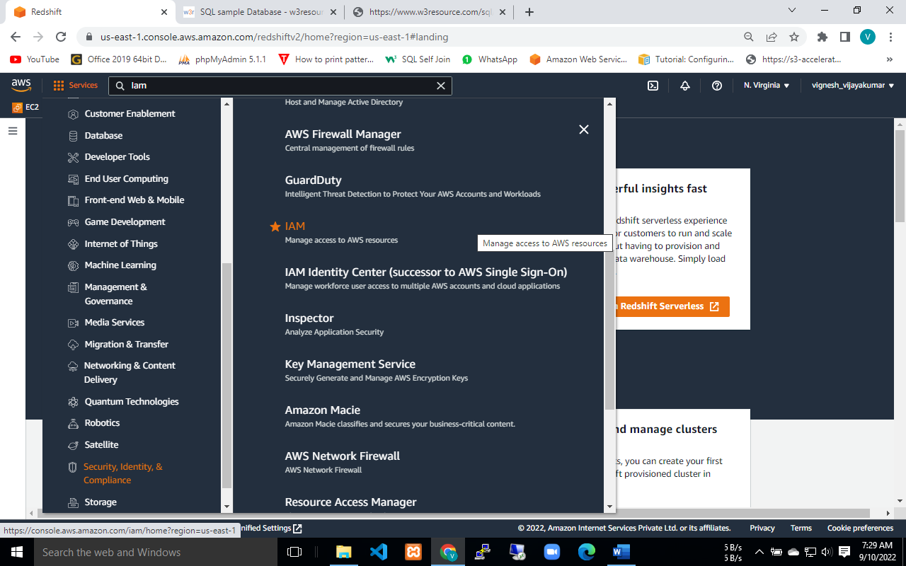

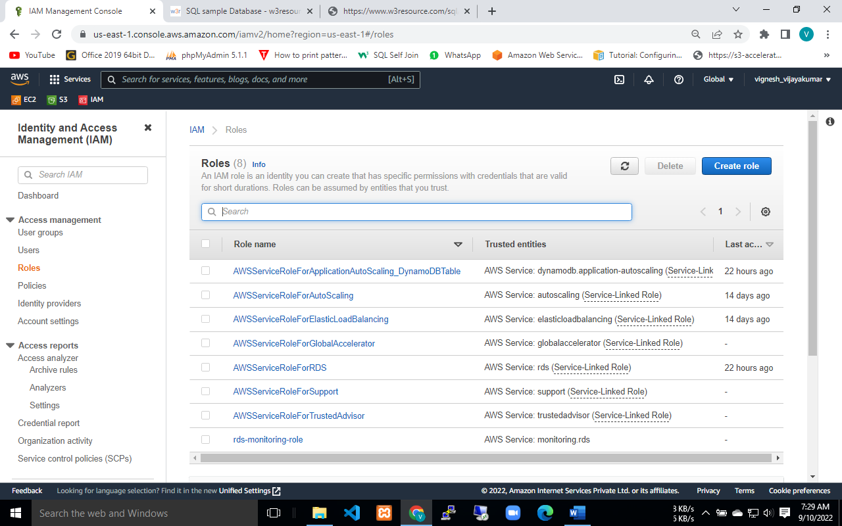

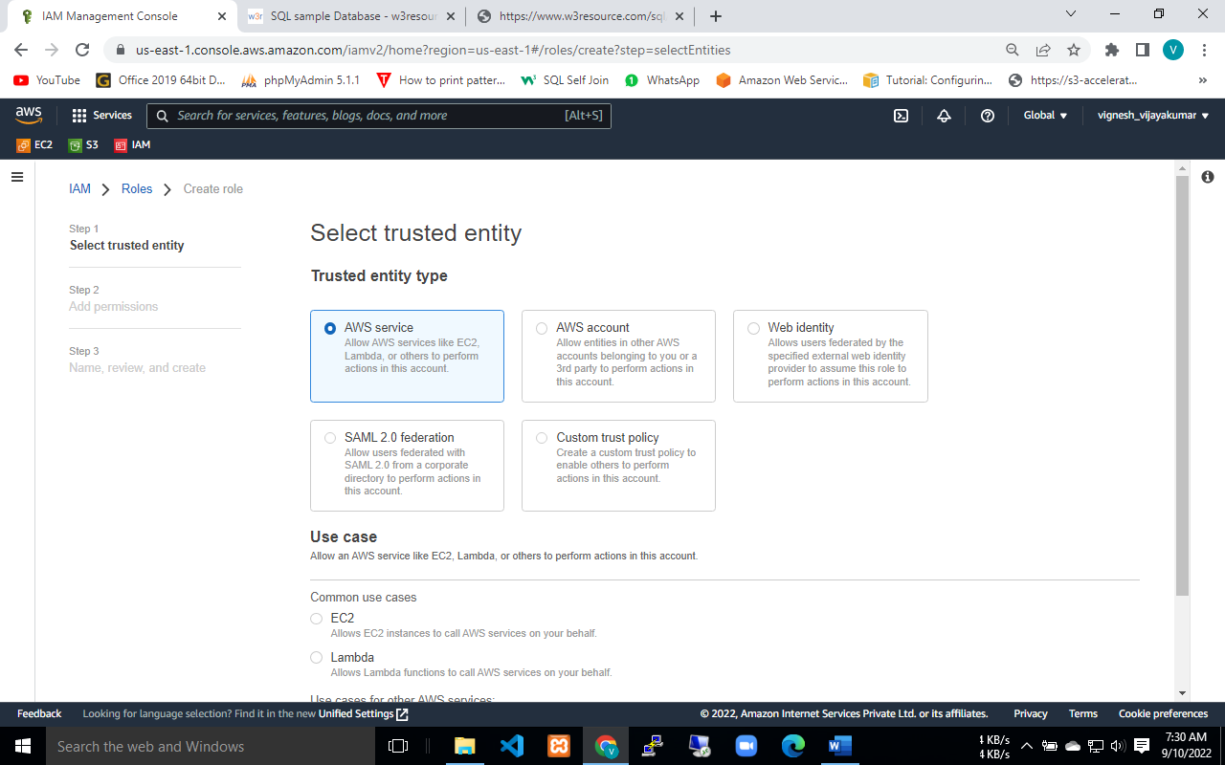

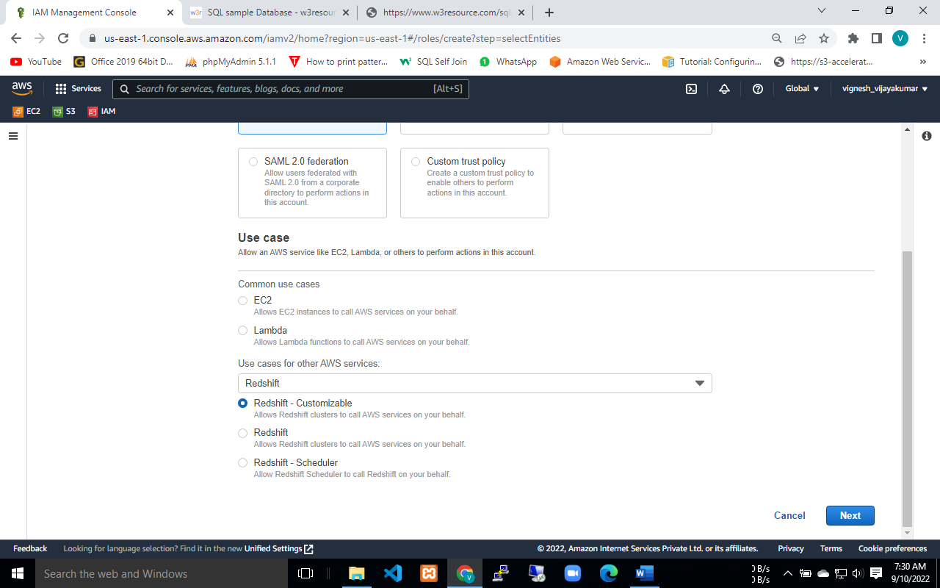

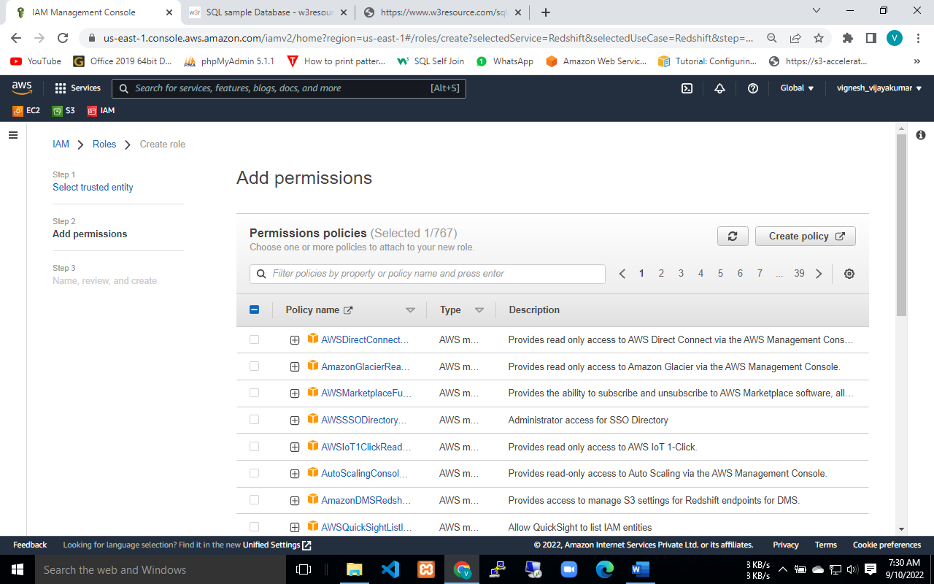

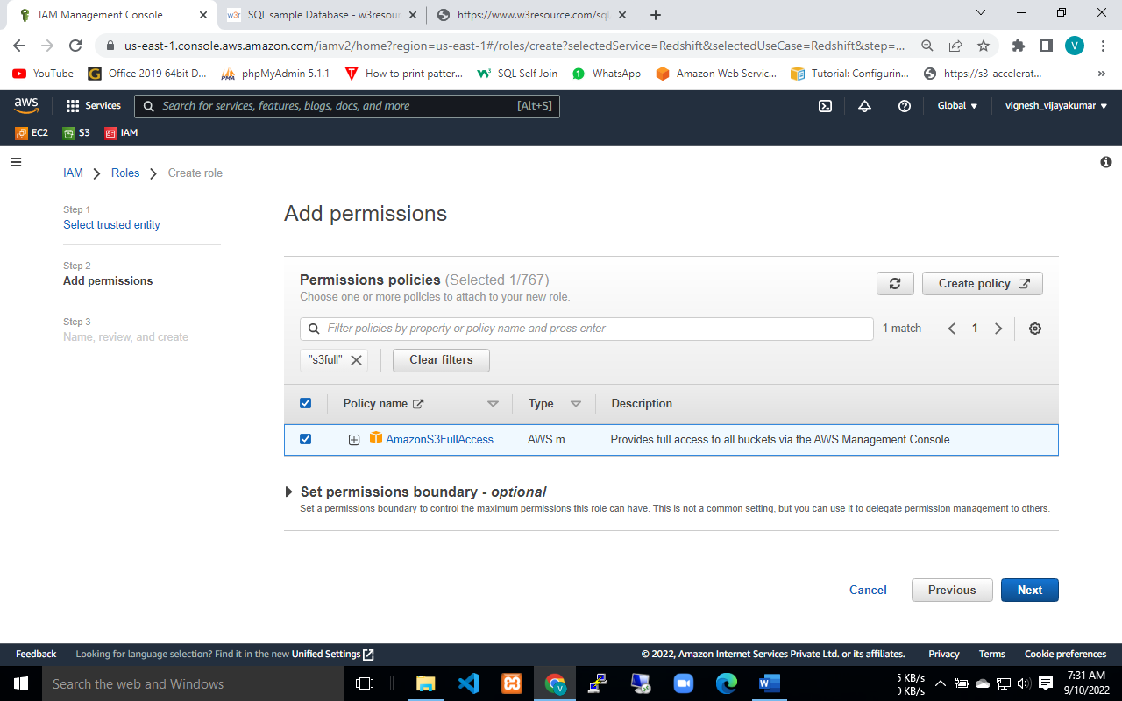

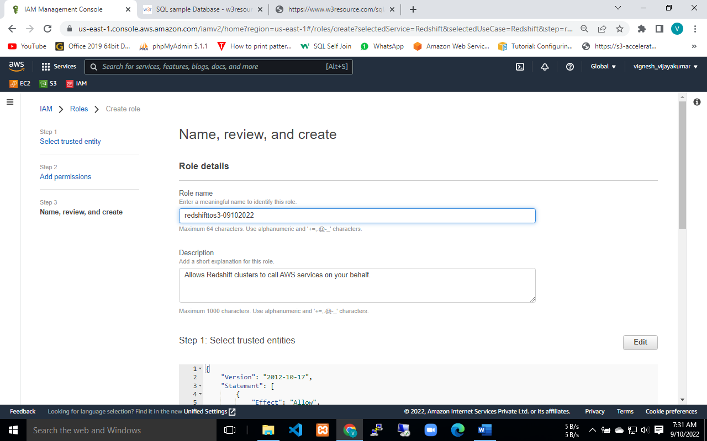

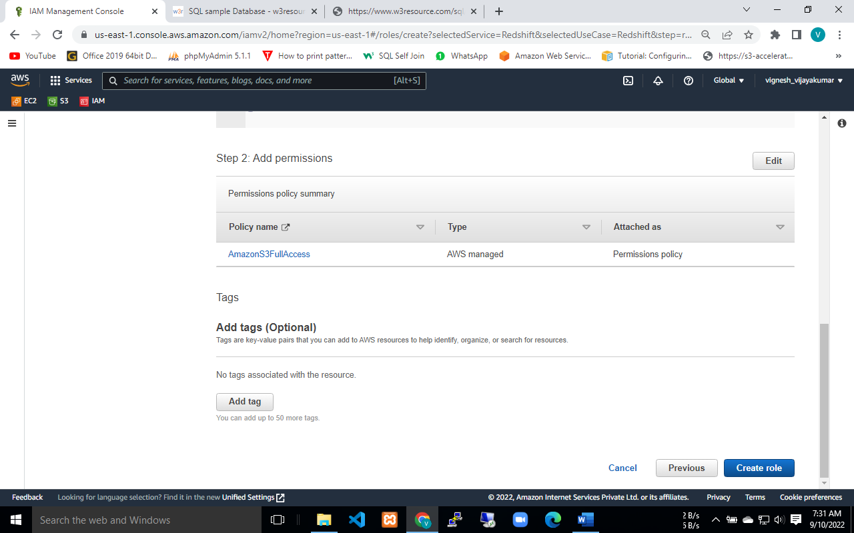

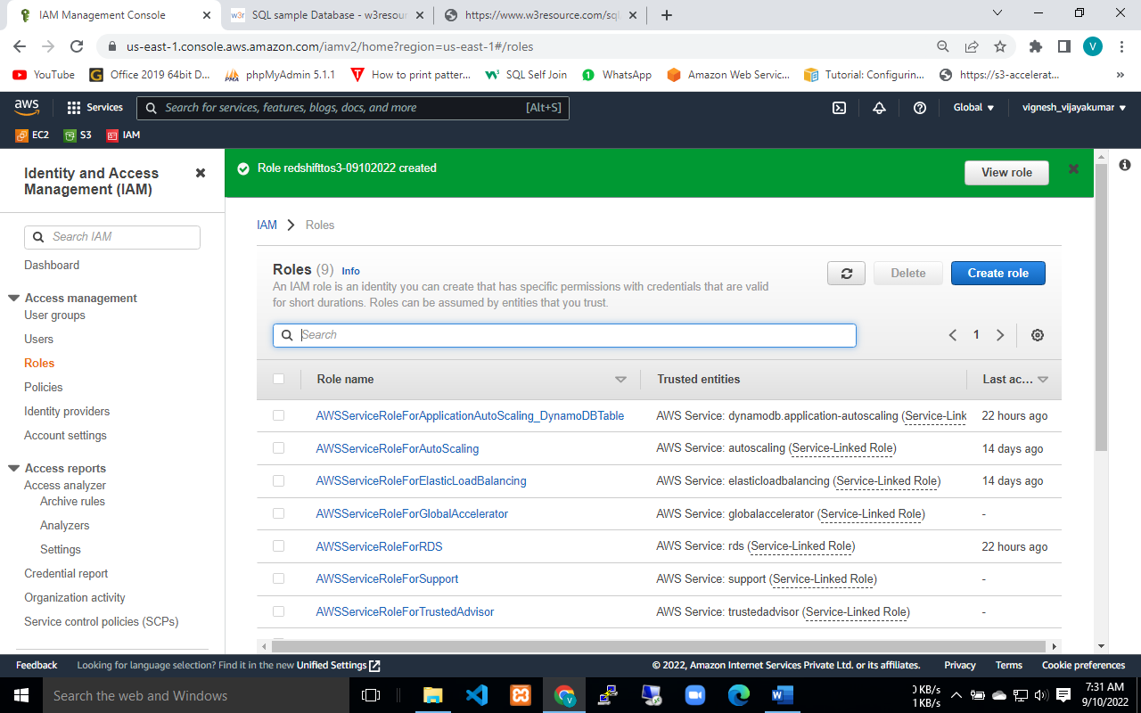

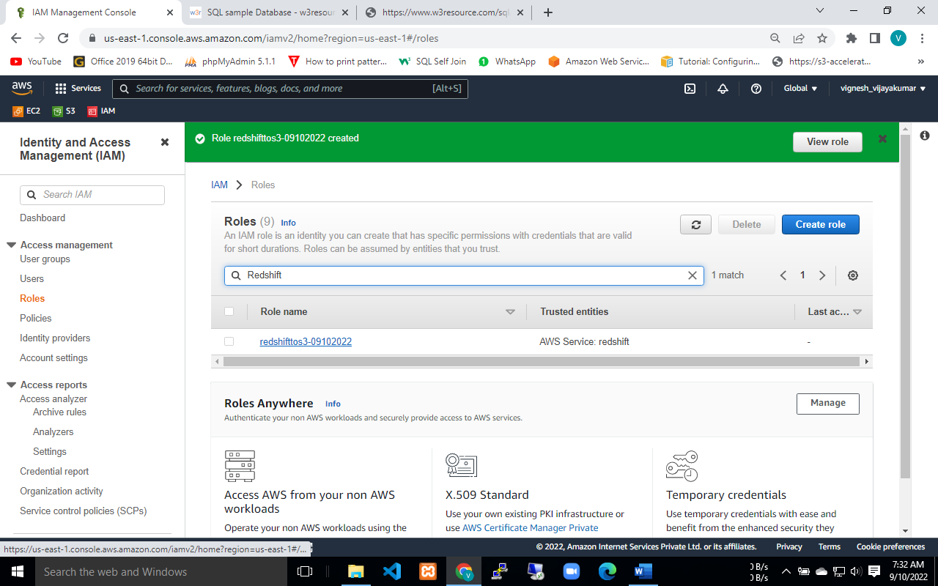

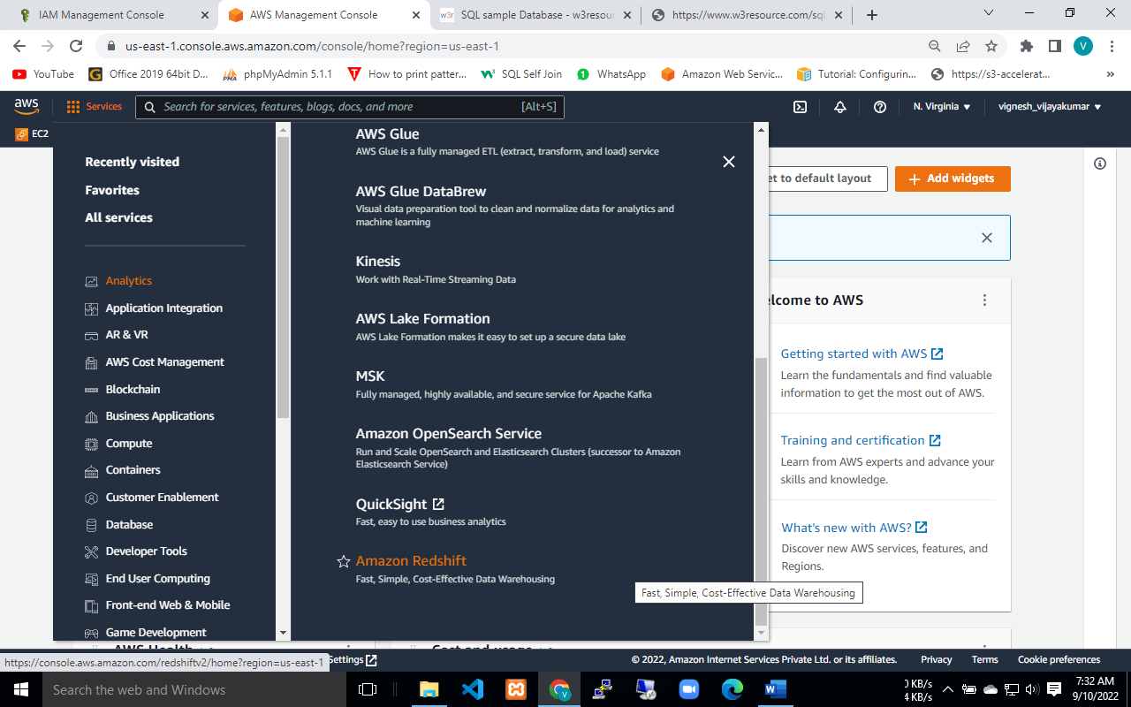

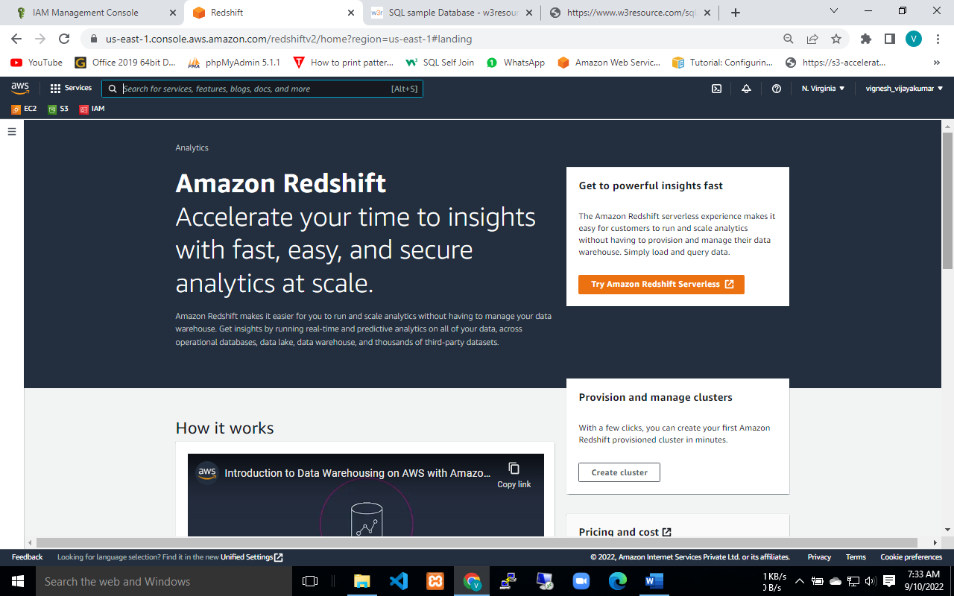

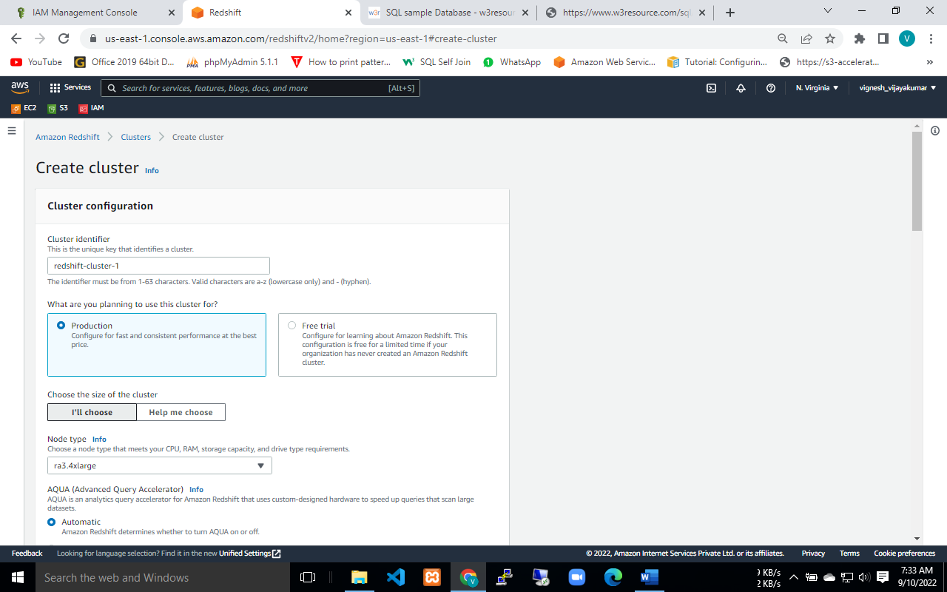

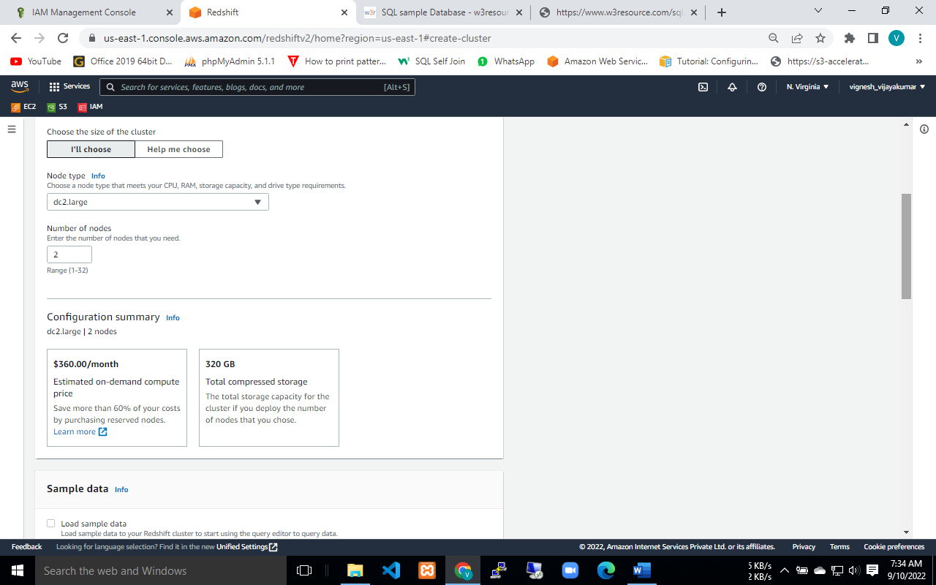

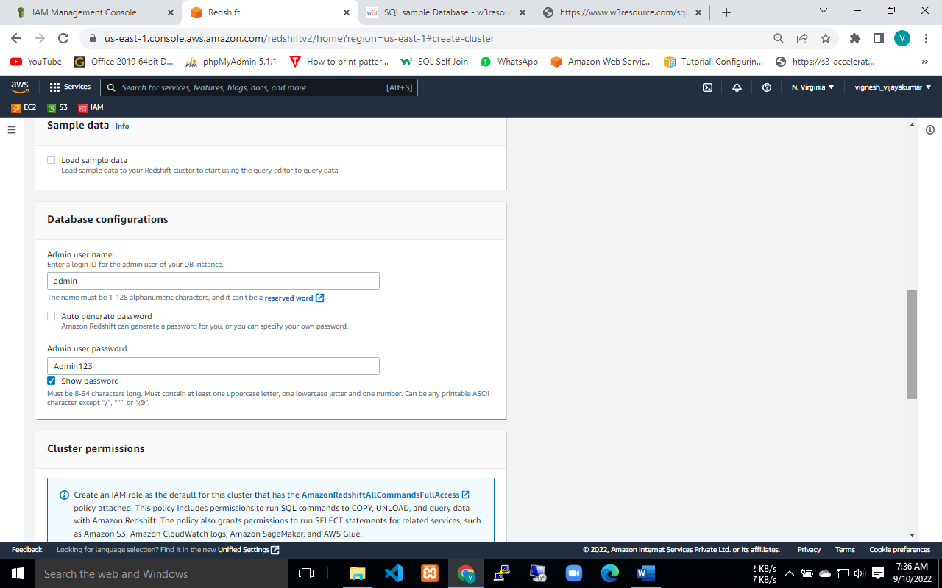

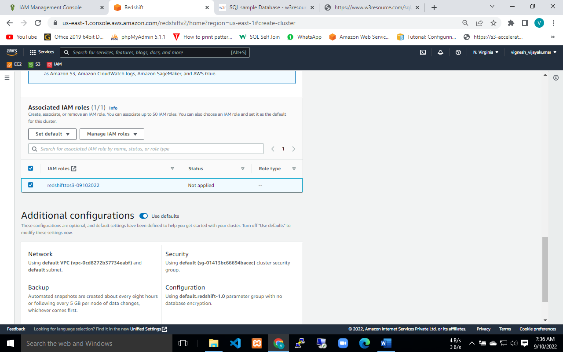

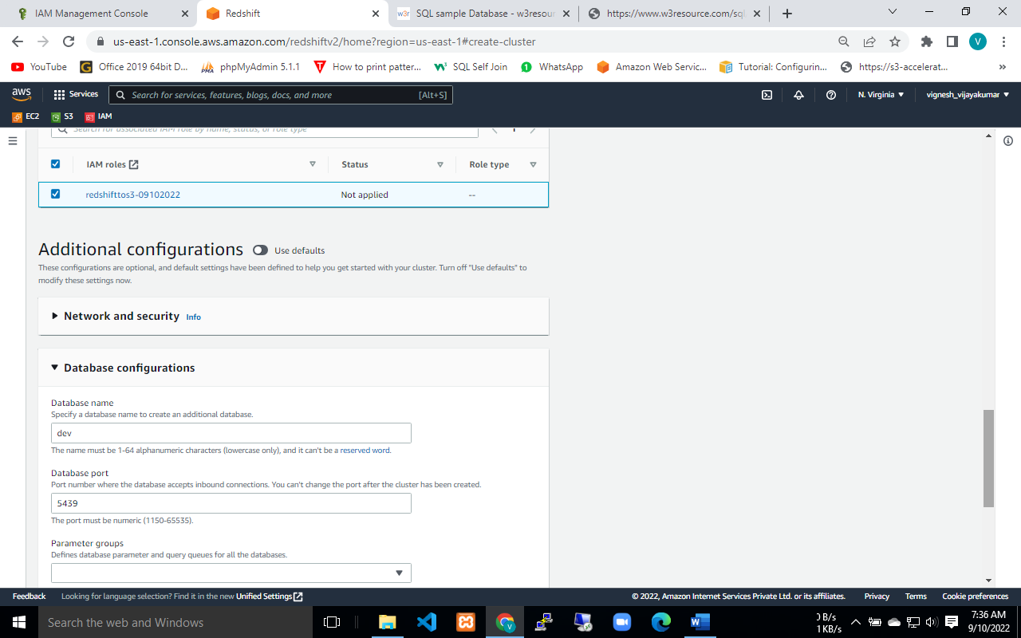

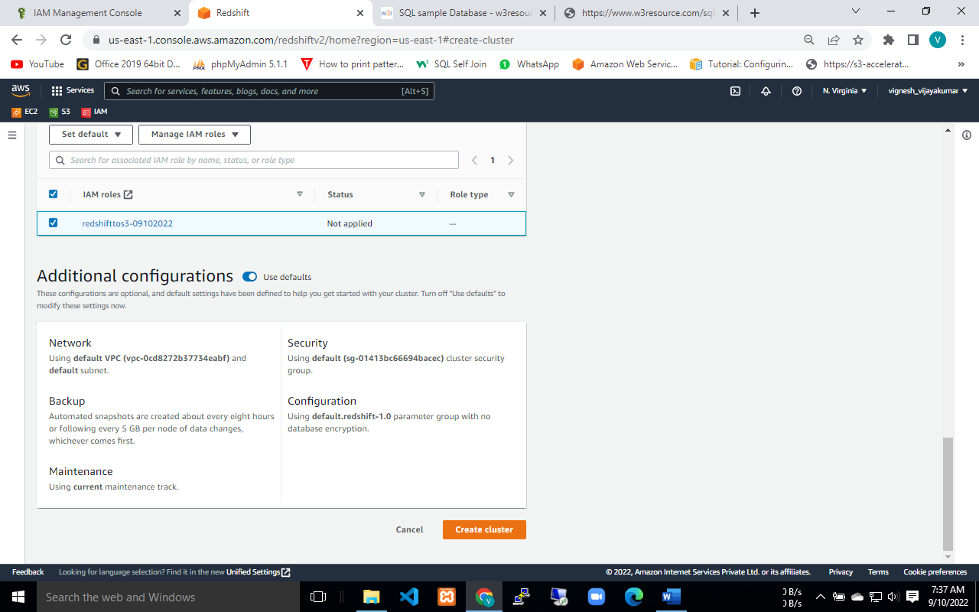

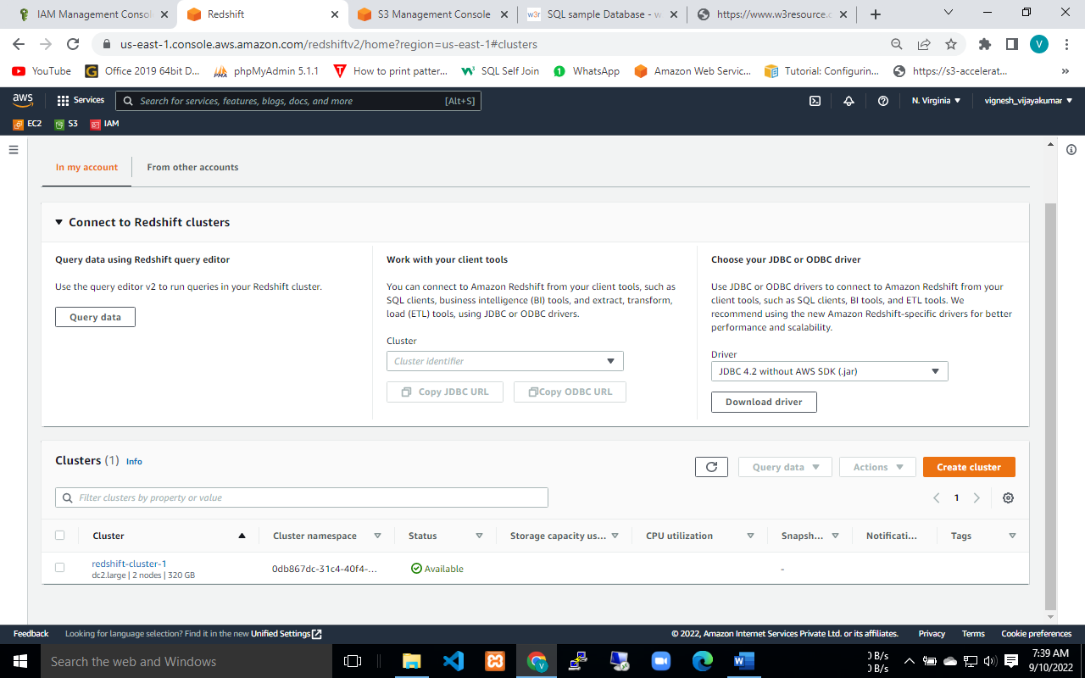

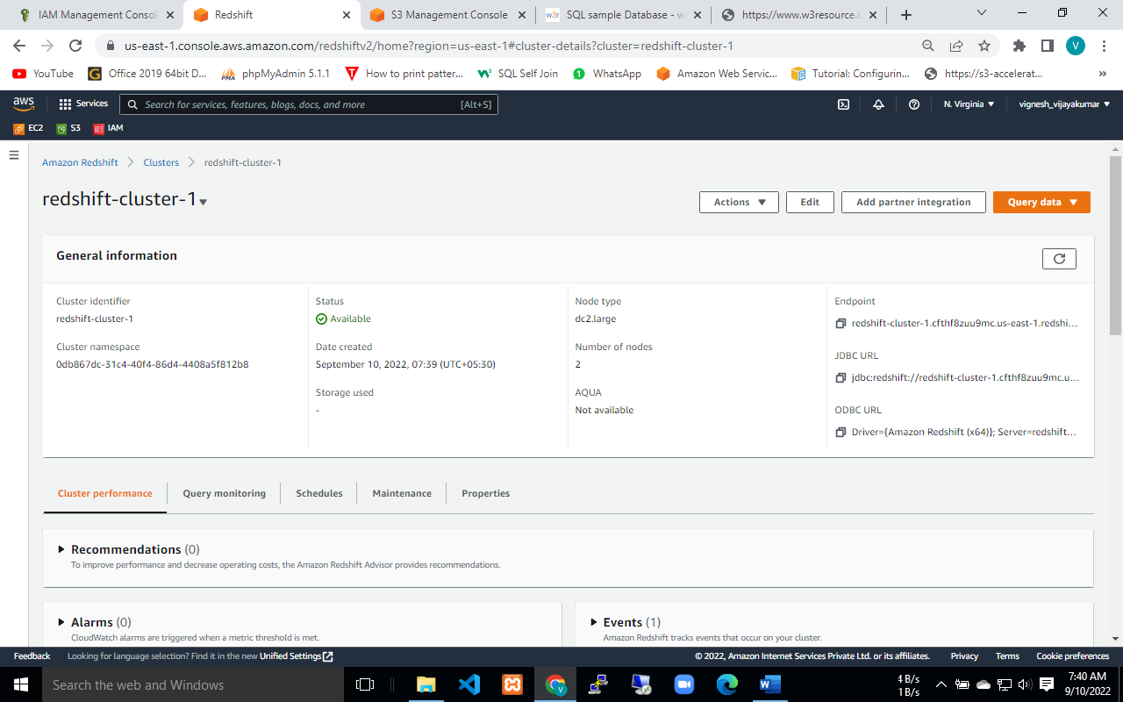

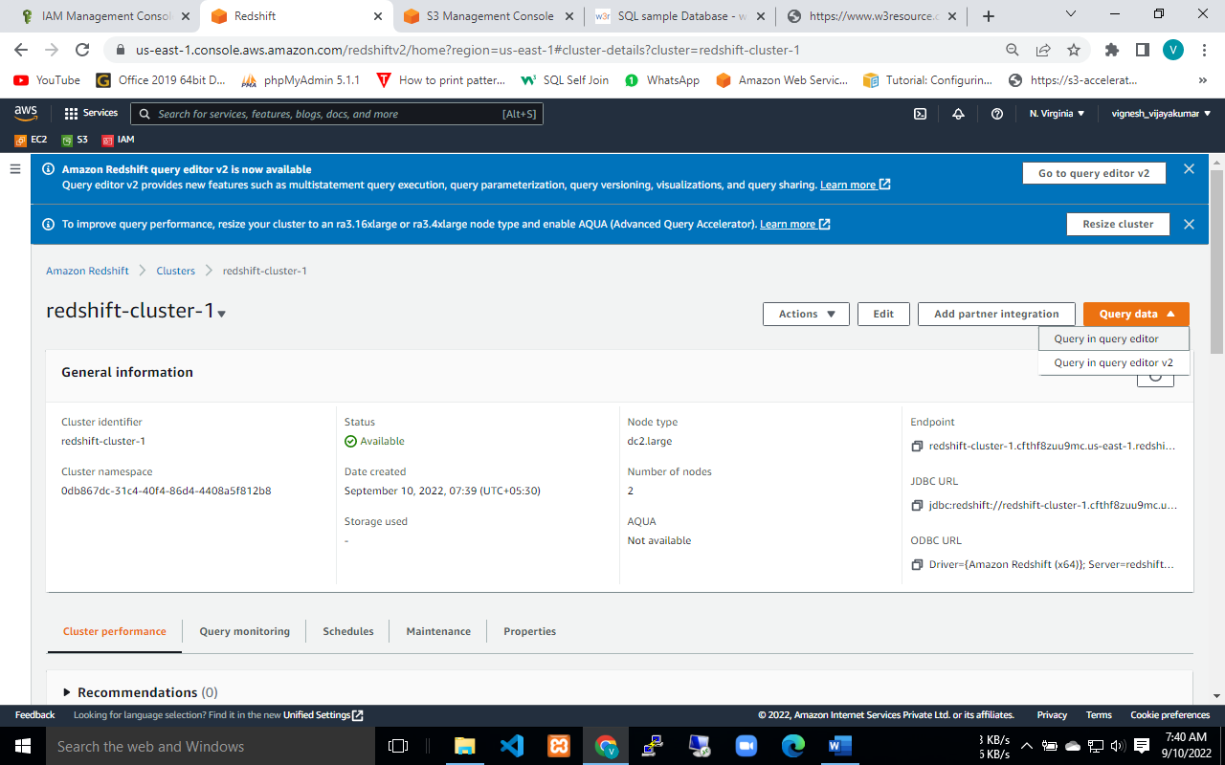

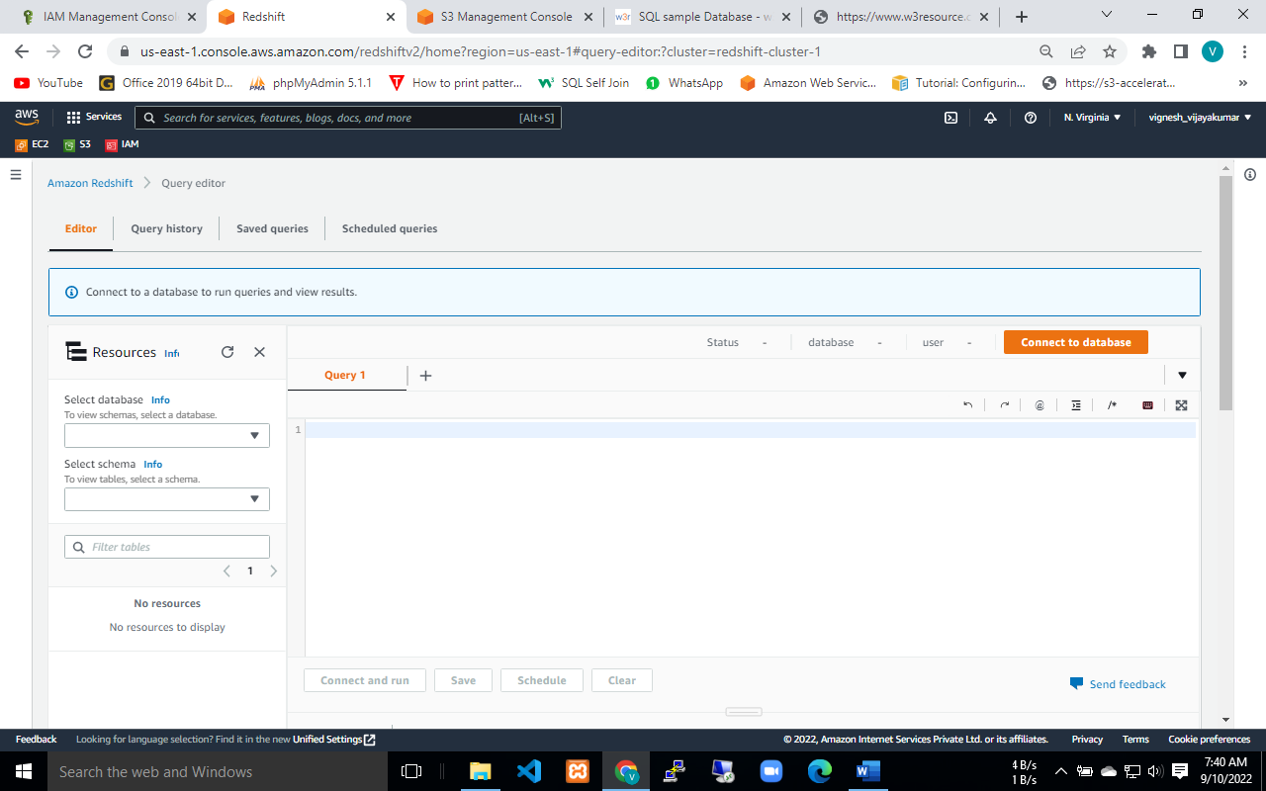

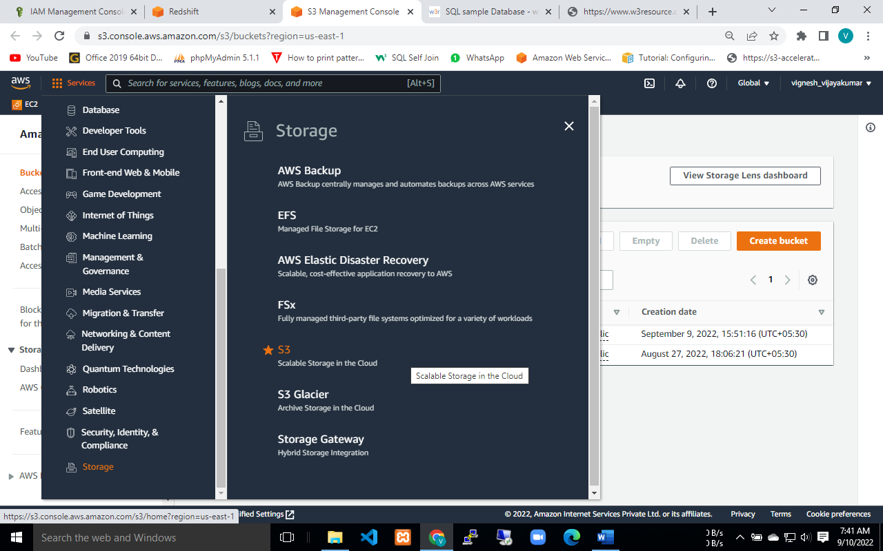

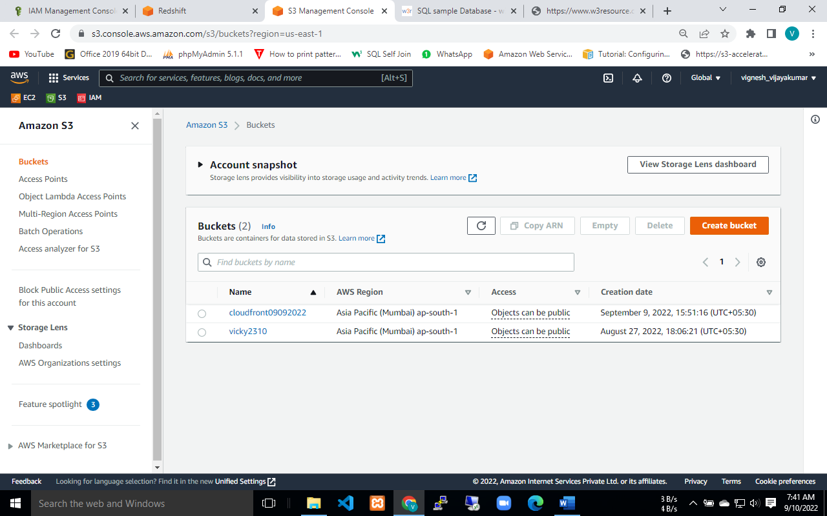

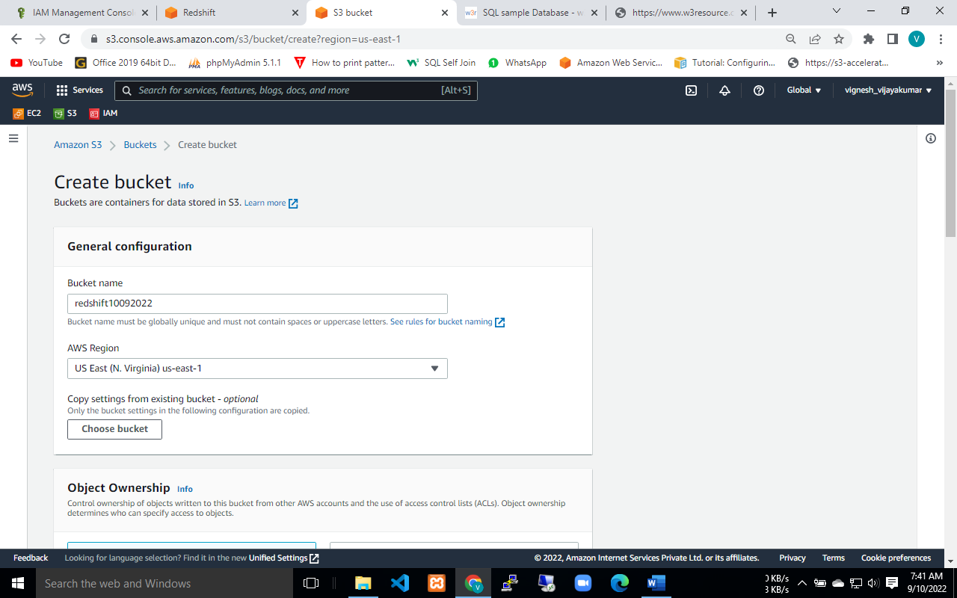

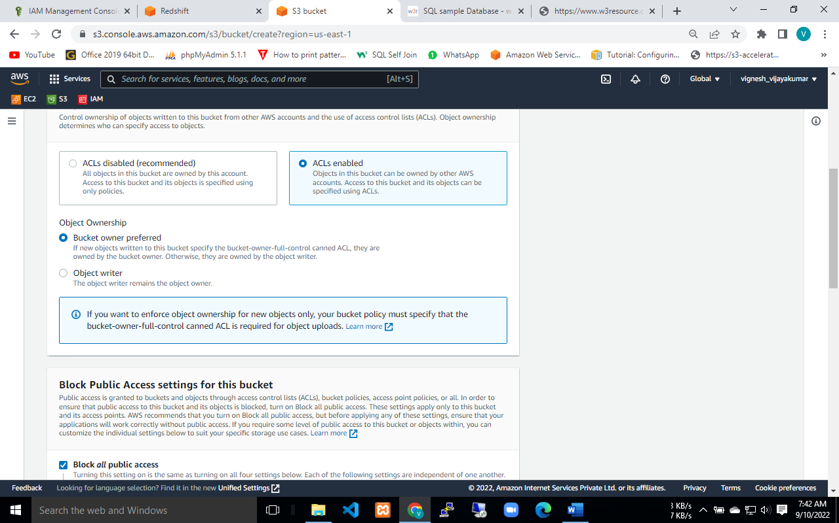

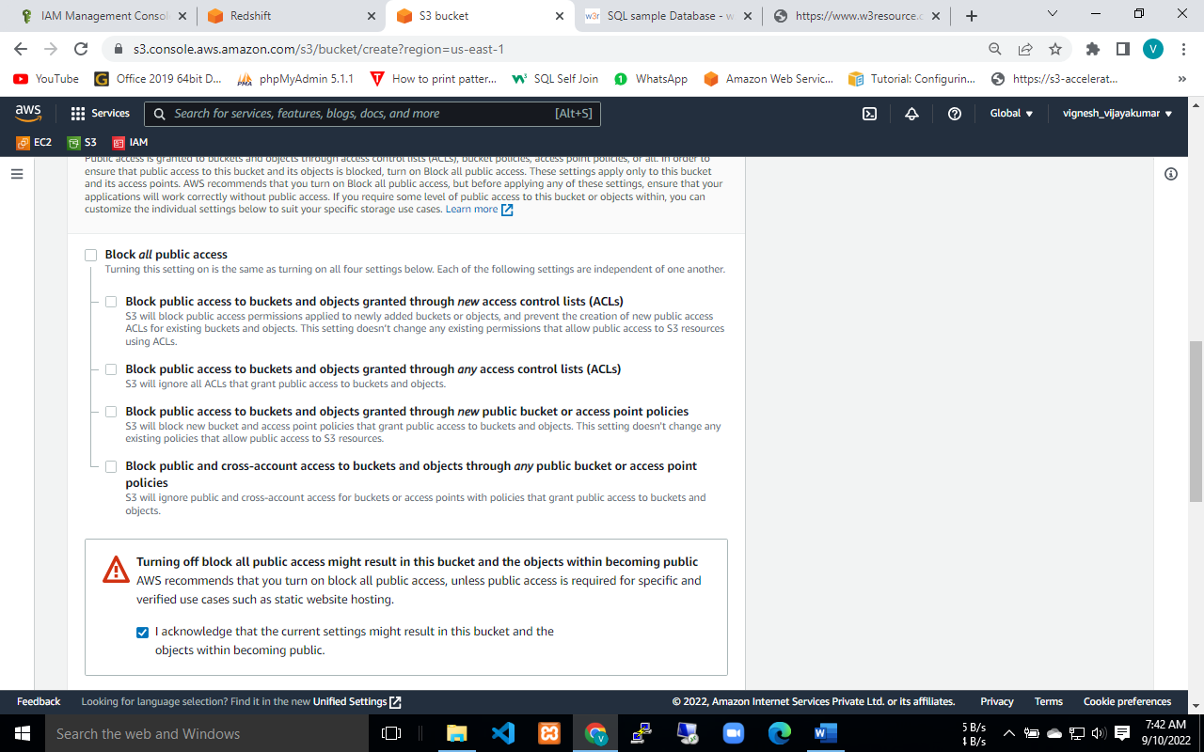

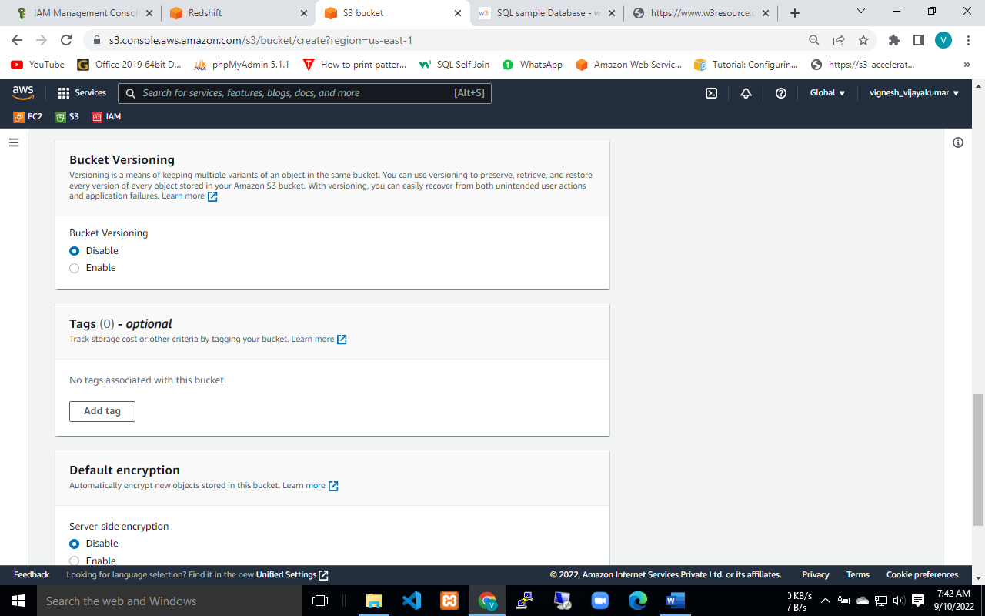

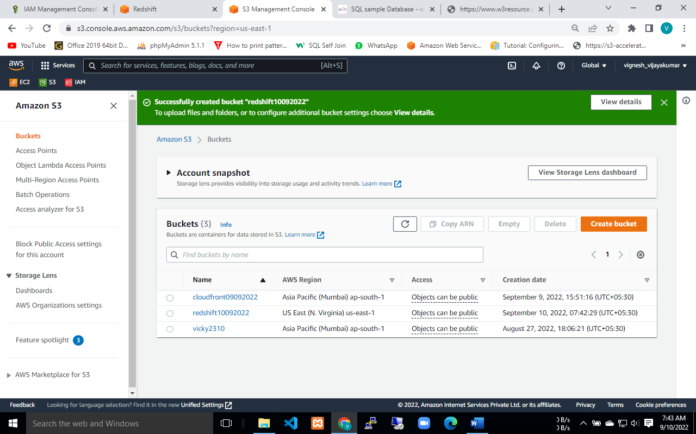

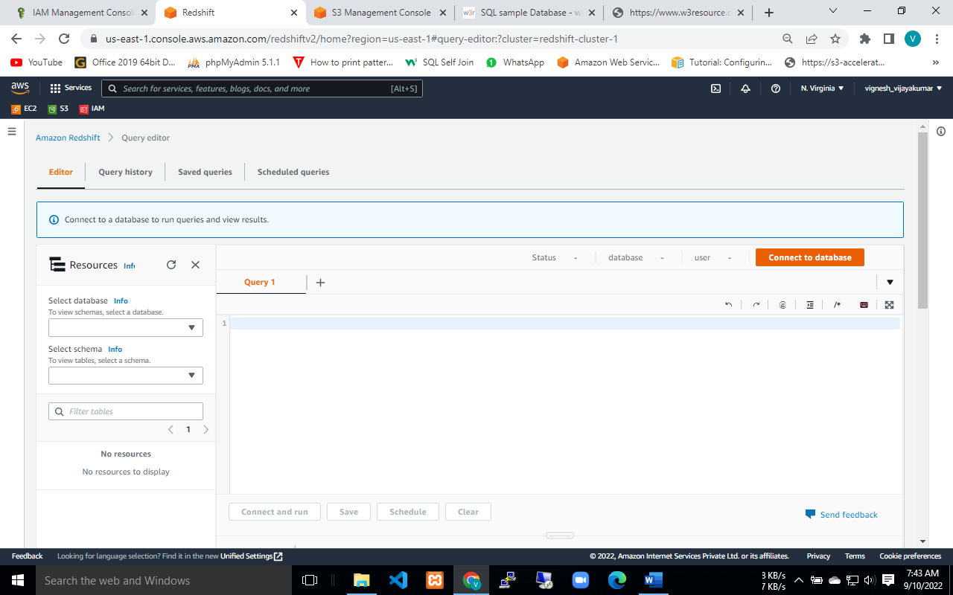

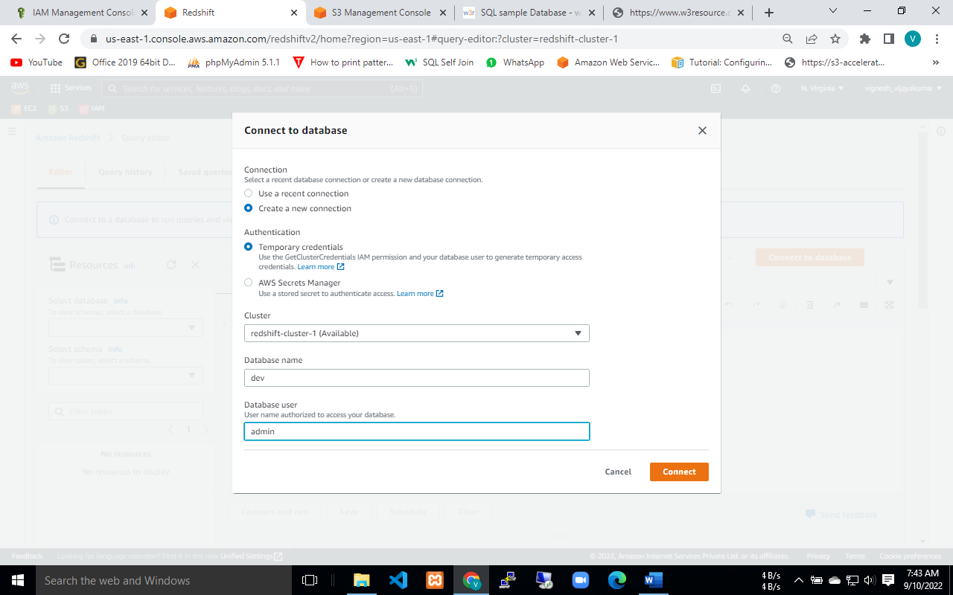

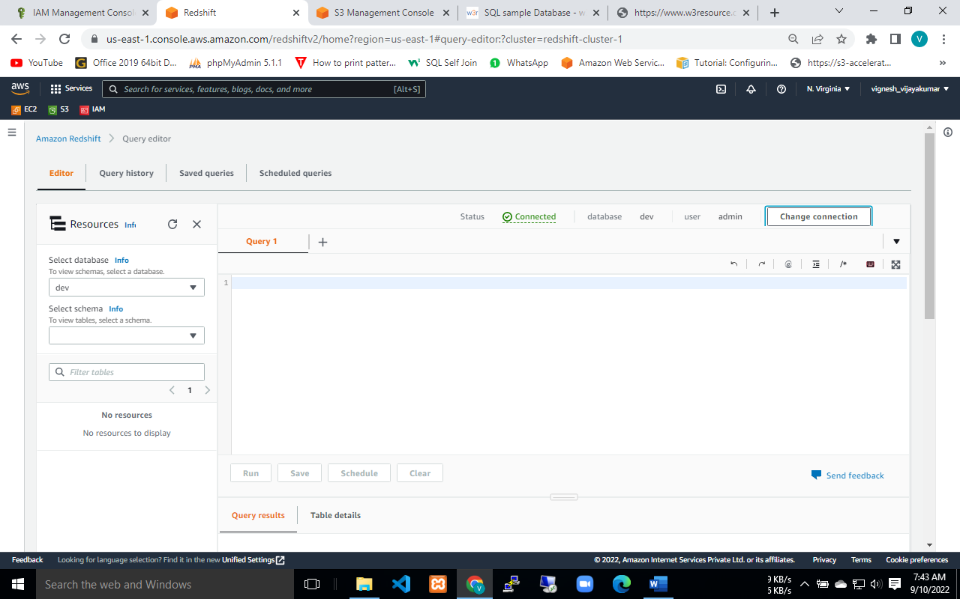

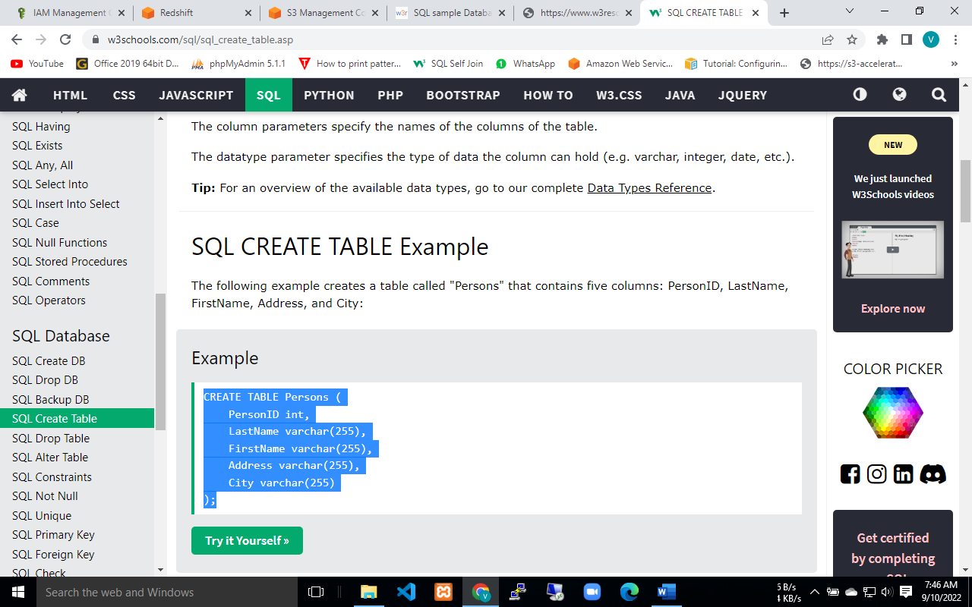

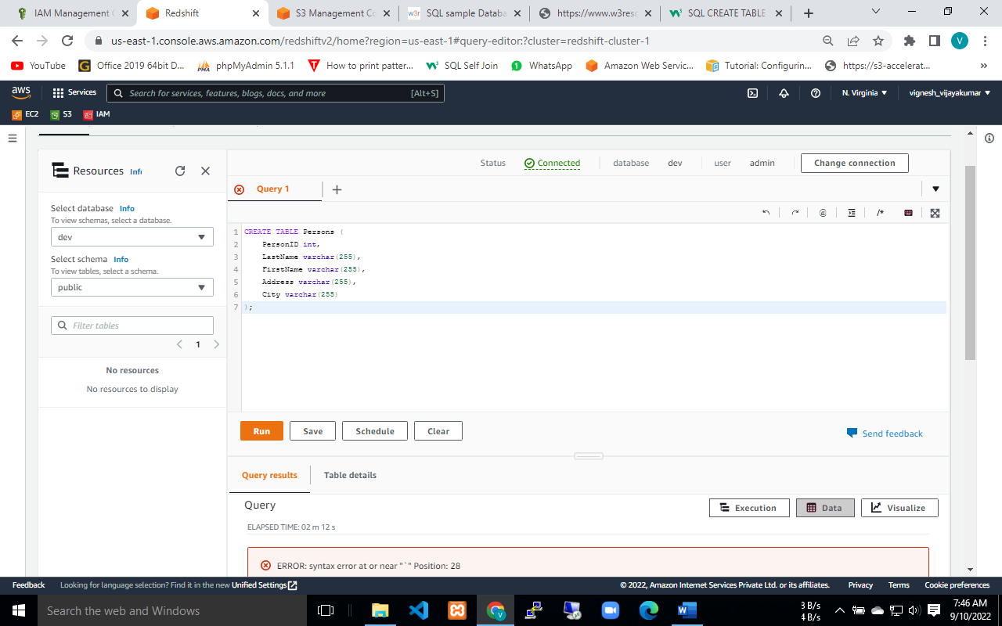

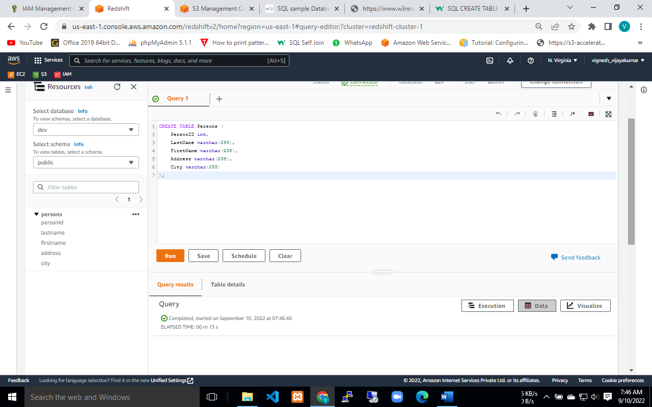

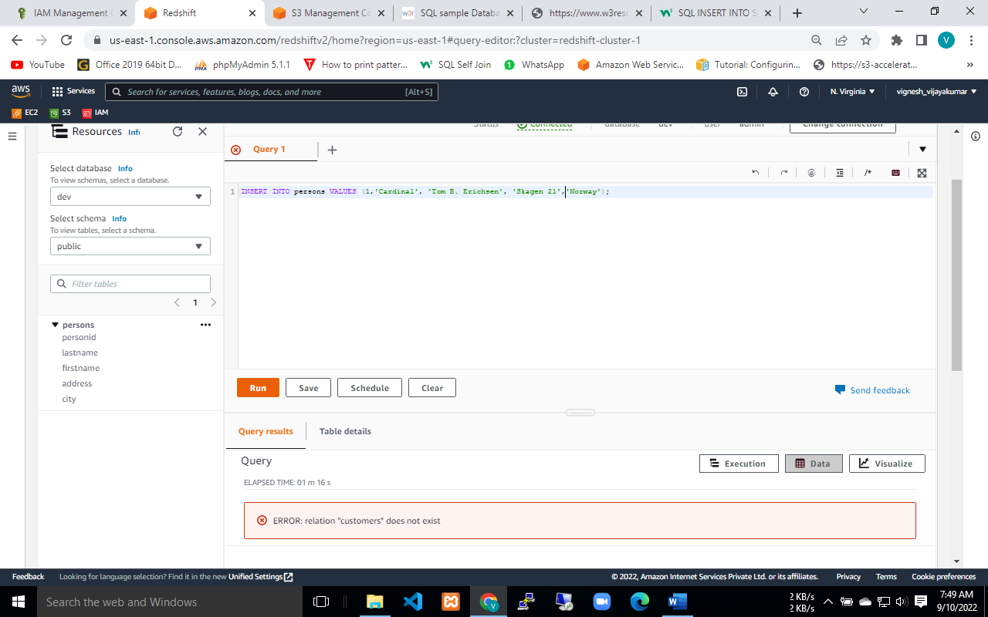

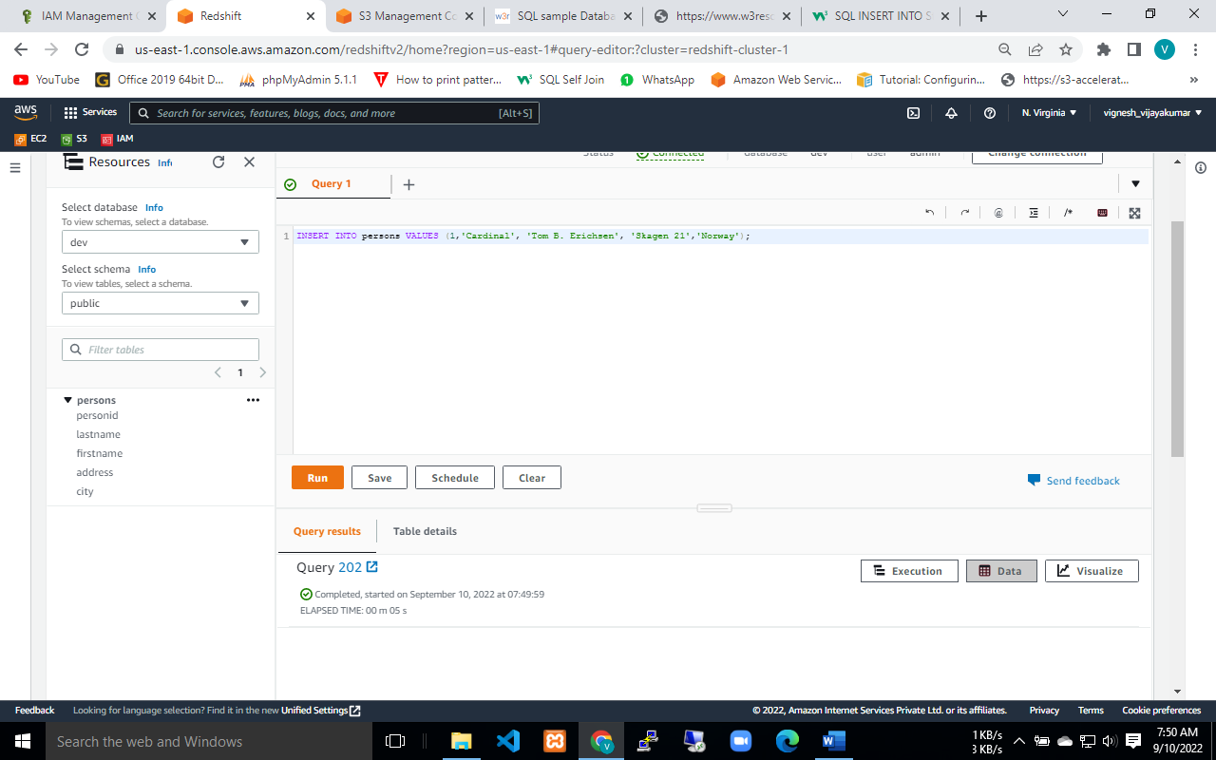

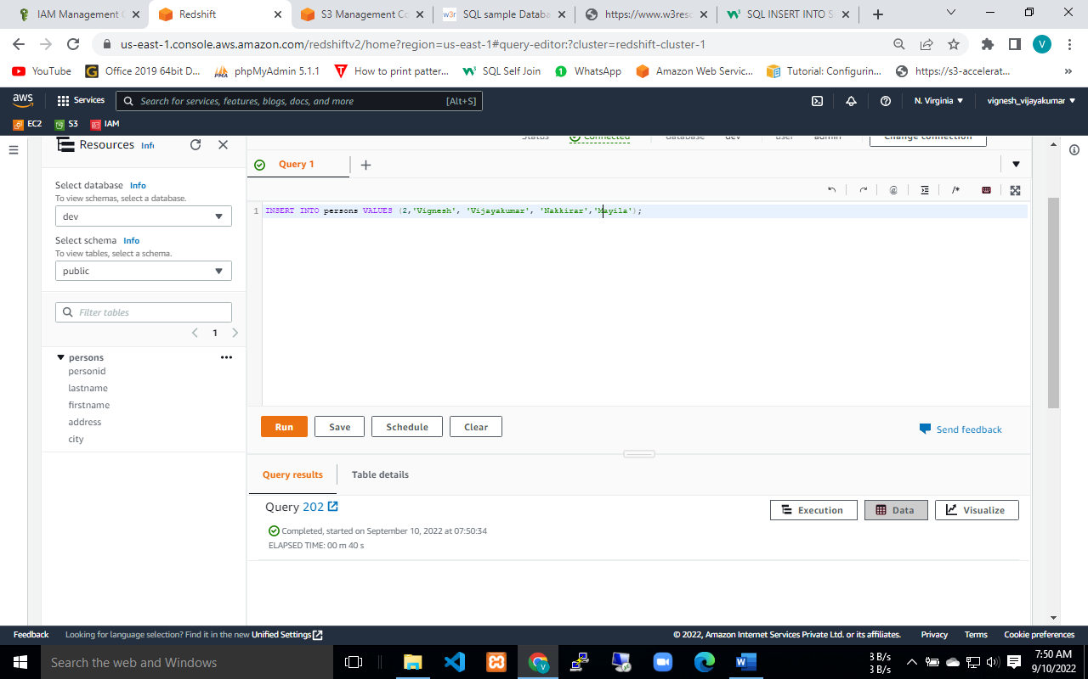

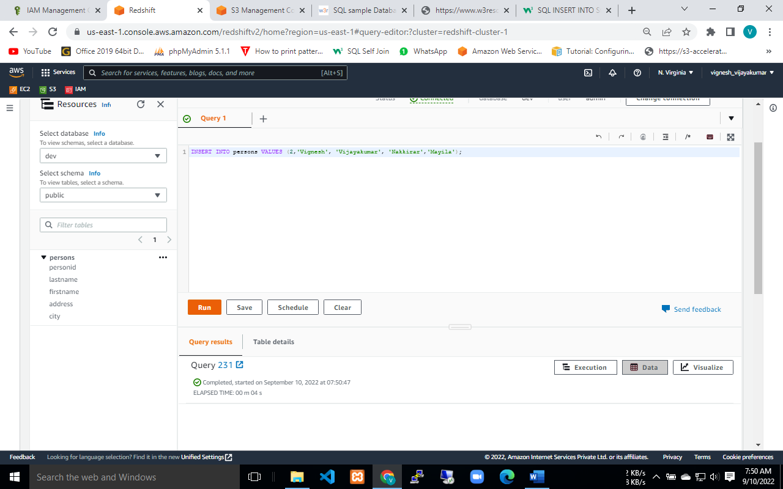

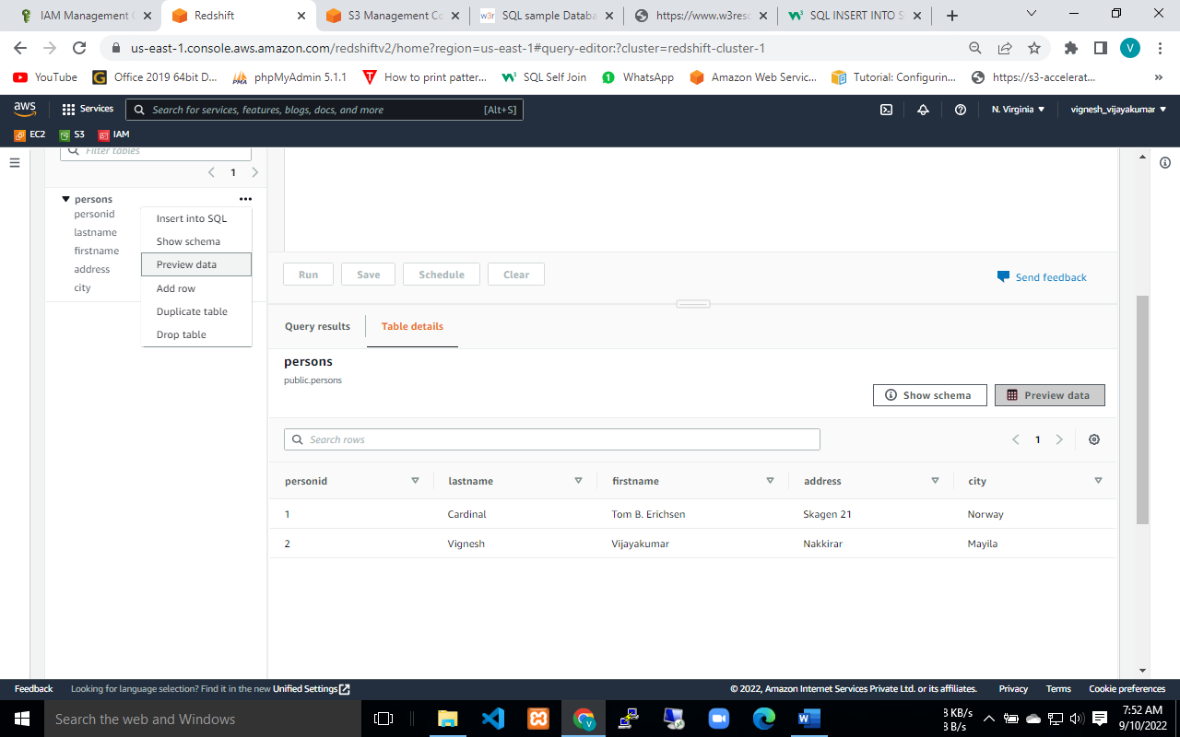

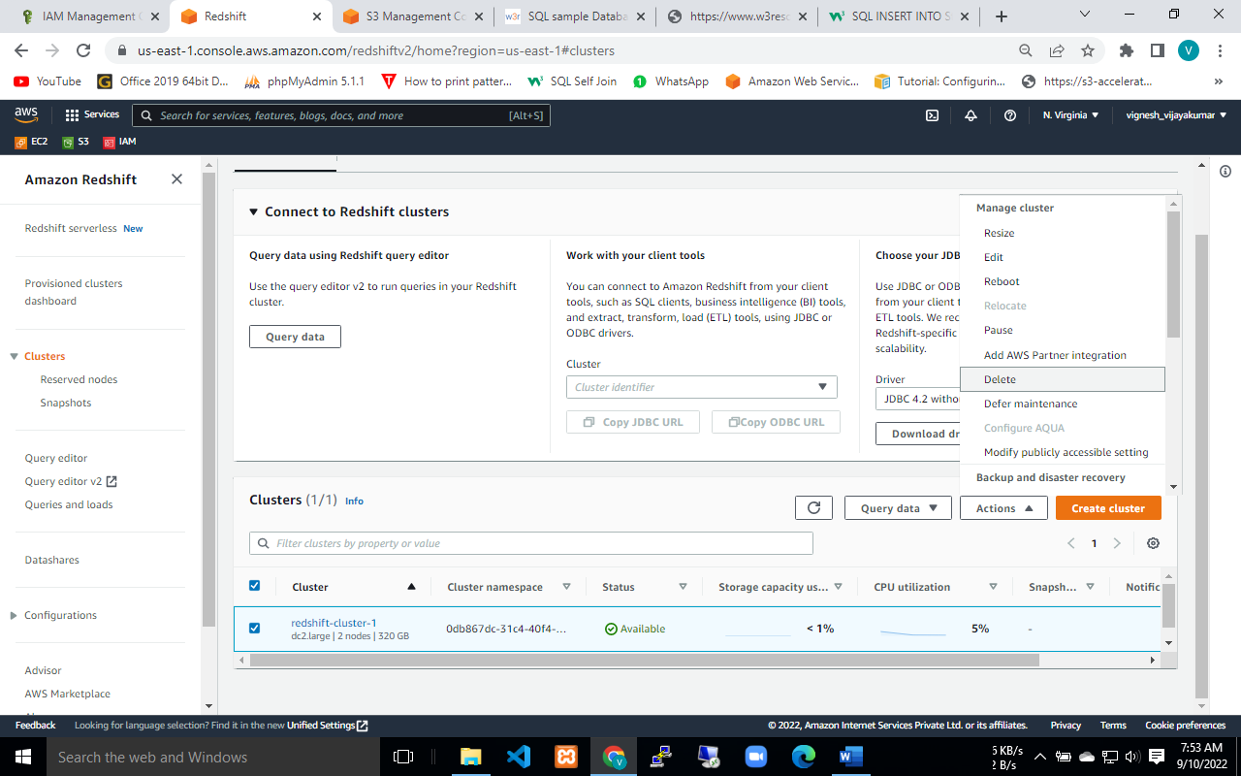

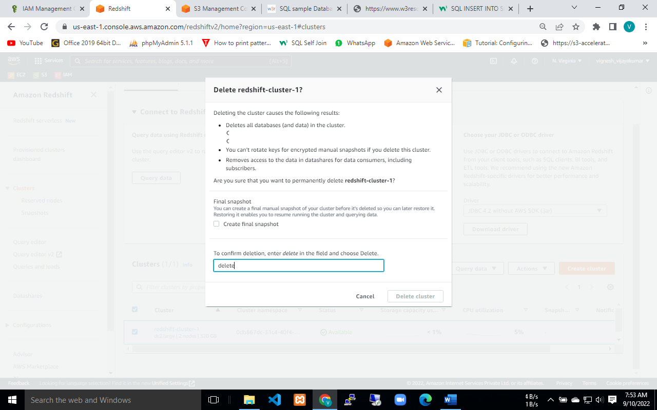

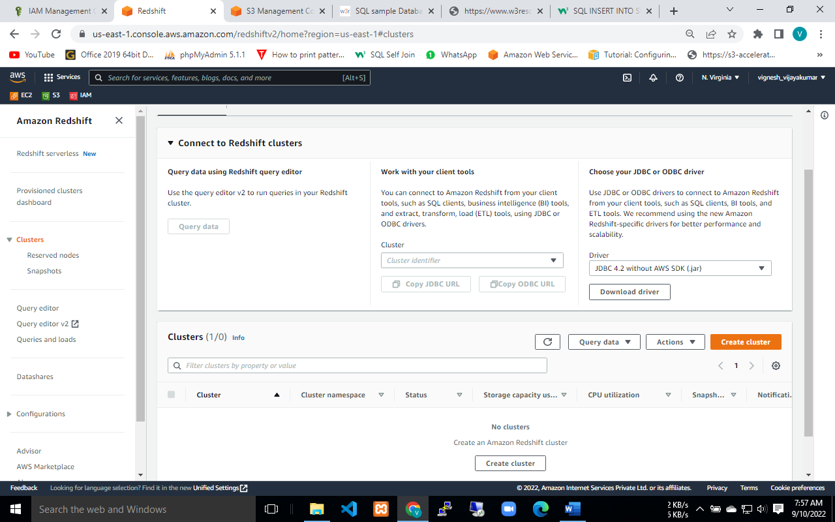

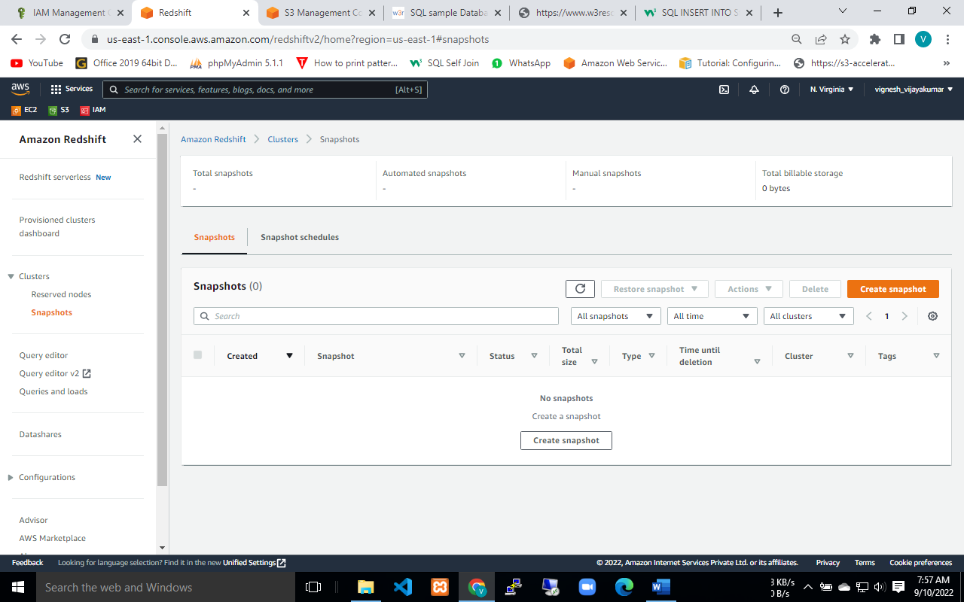

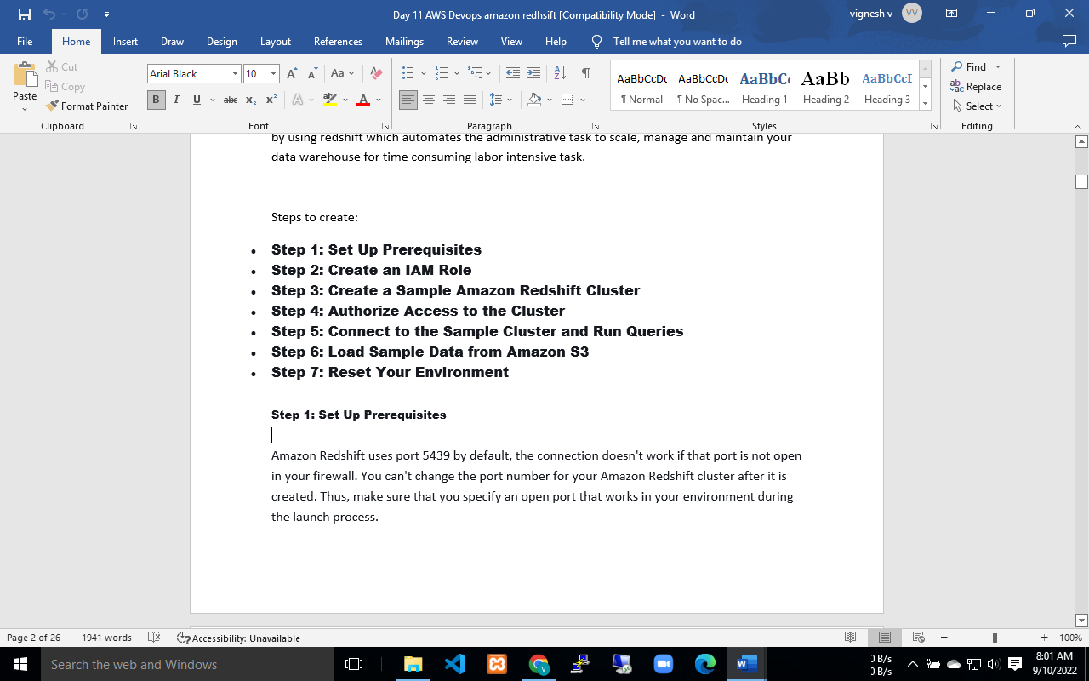

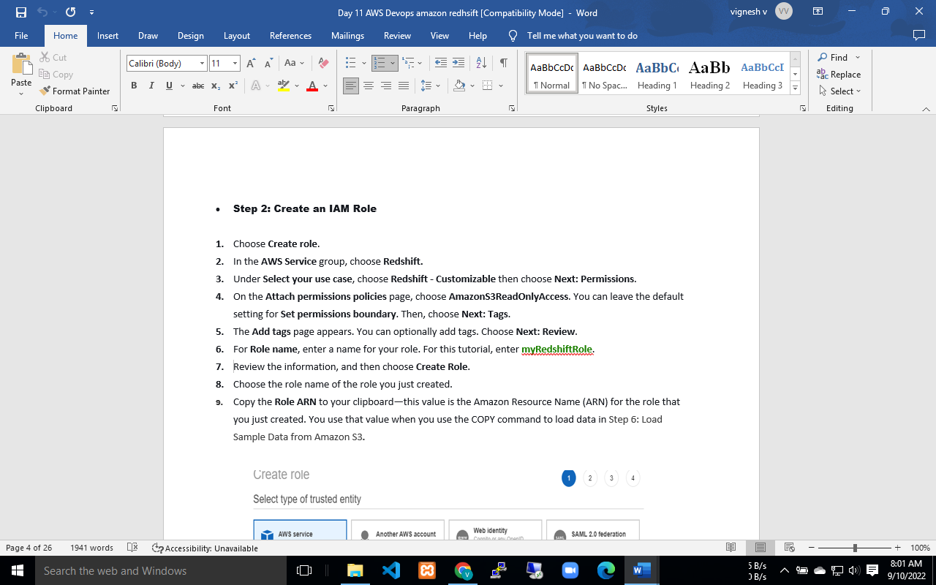

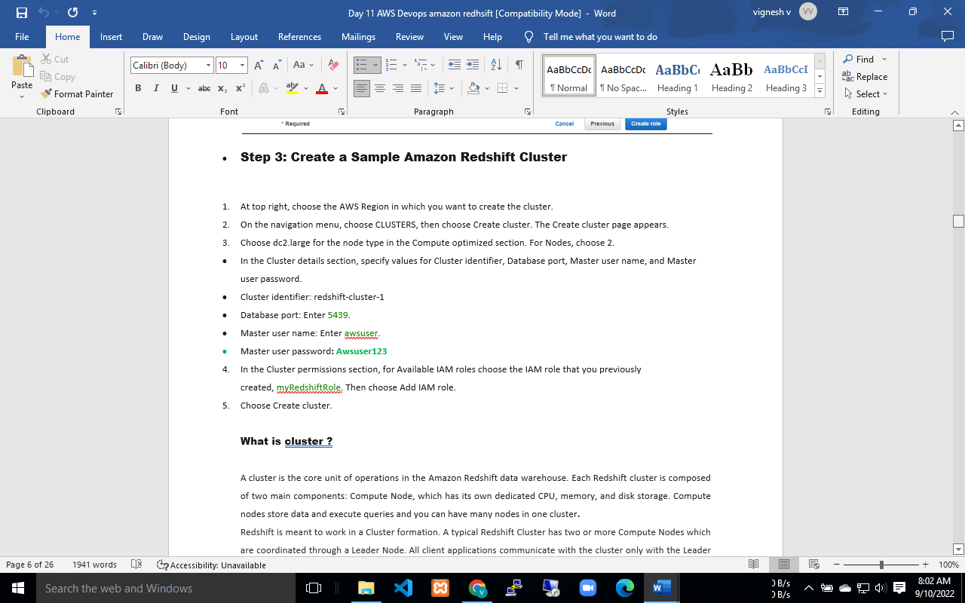

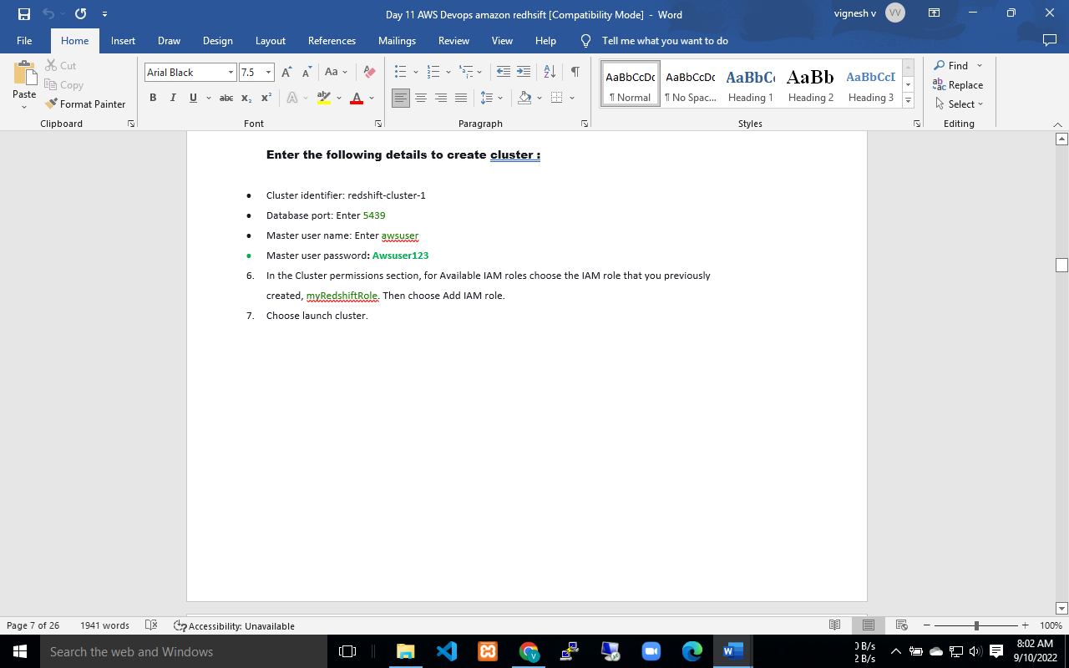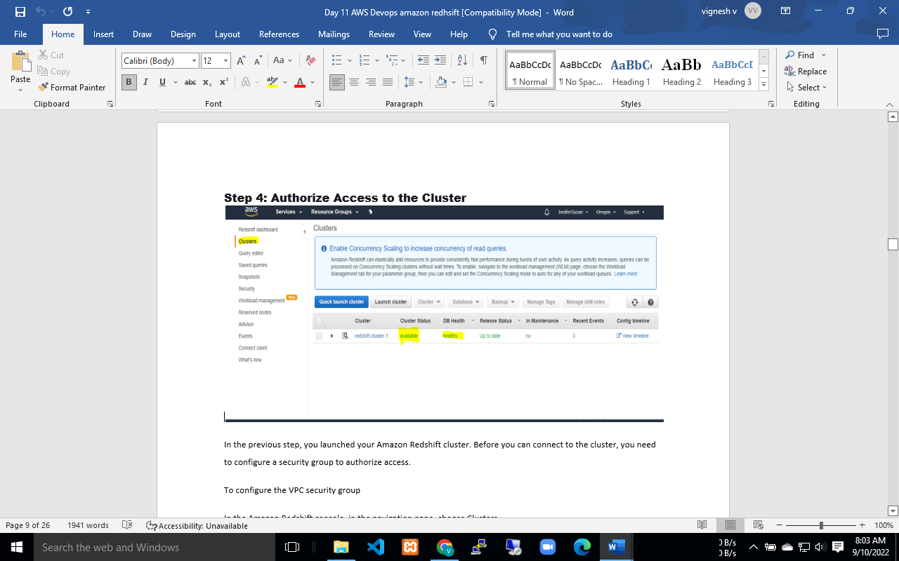

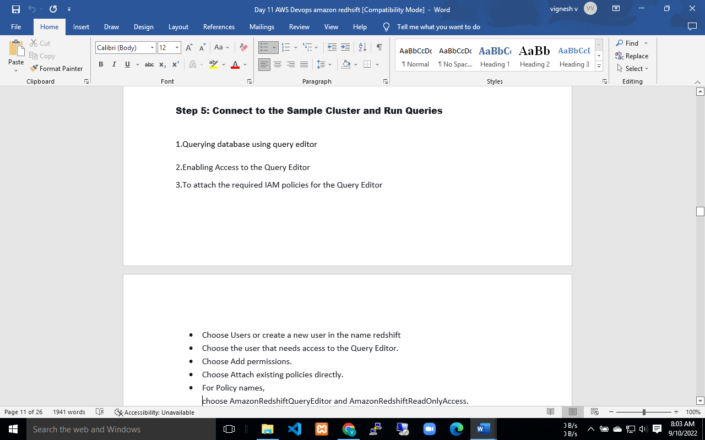

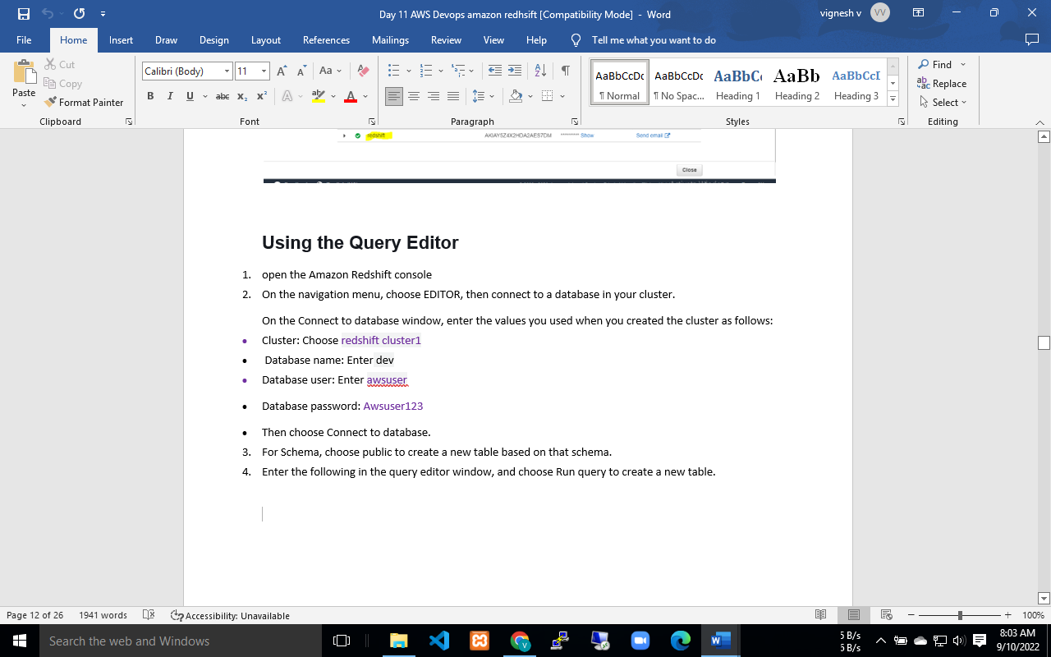

Goto redshift console page in query editor

Add the following with copy commands

copy users from 's3://*<myBucket>*/allusers_pipe.txt'

credentials 'aws_iam_role=*<iam-role-arn>*'

delimiter '|' region '*<aws-region>*';

change the bucket name and region name.

copy this ARN number of IAM role which you created earlier and paste it in query editor

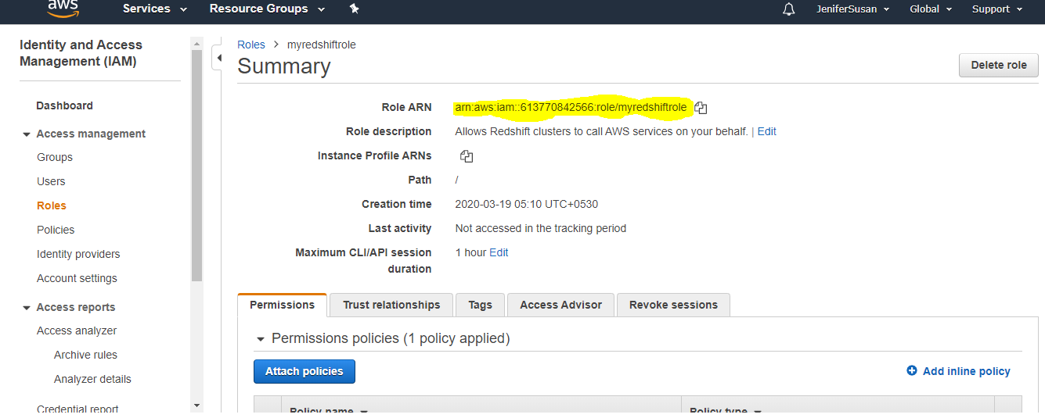

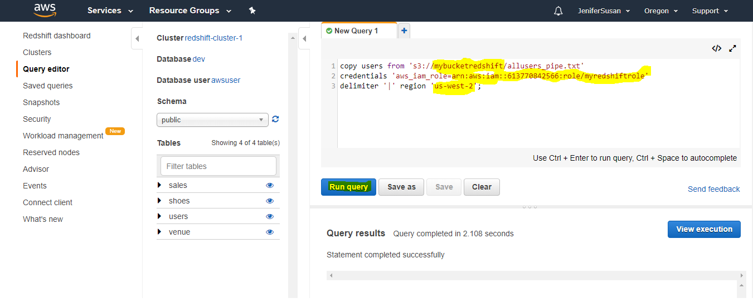

Now try to add some example queries.

SELECT *

FROM pg_table_def

WHERE tablename = 'users';

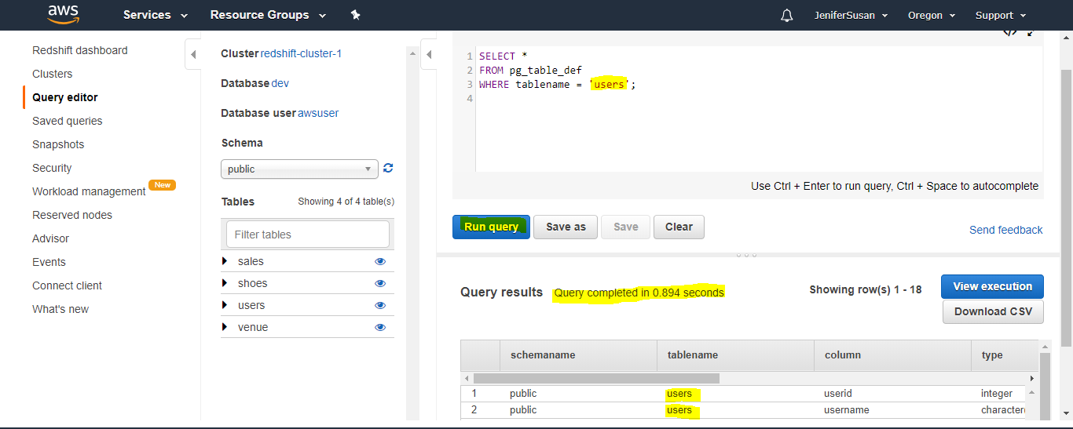

SELECT *

FROM users;

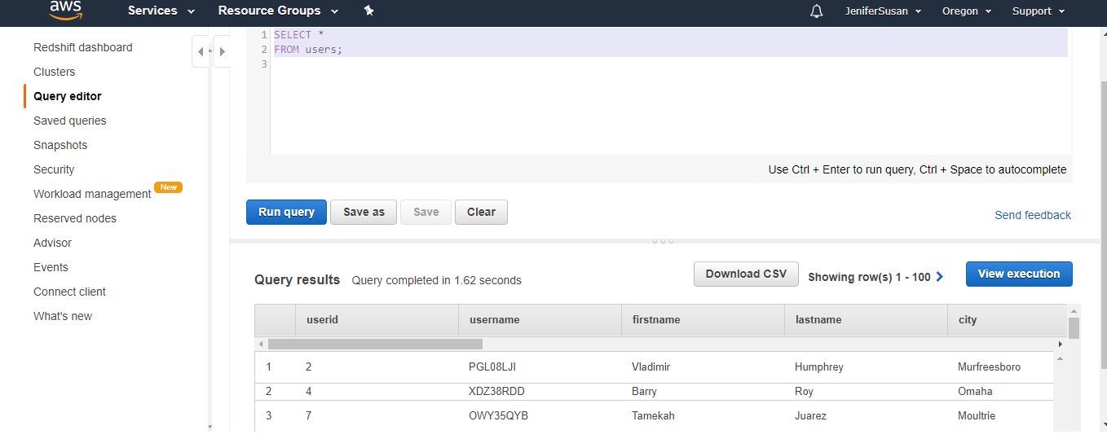

SELECT *

FROM users

where firstname = 'Vladimir';

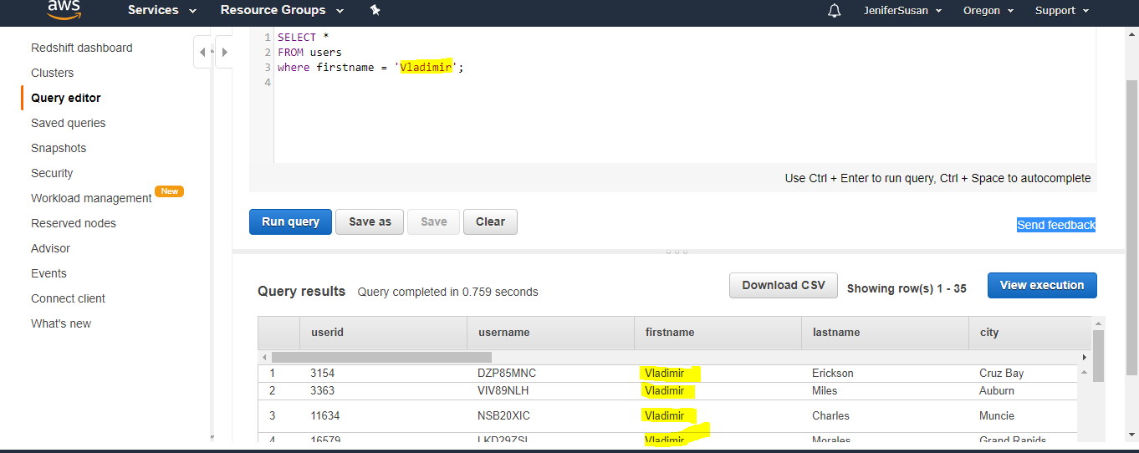

Goto back cluster  redshift-cluster-1 console page click queries

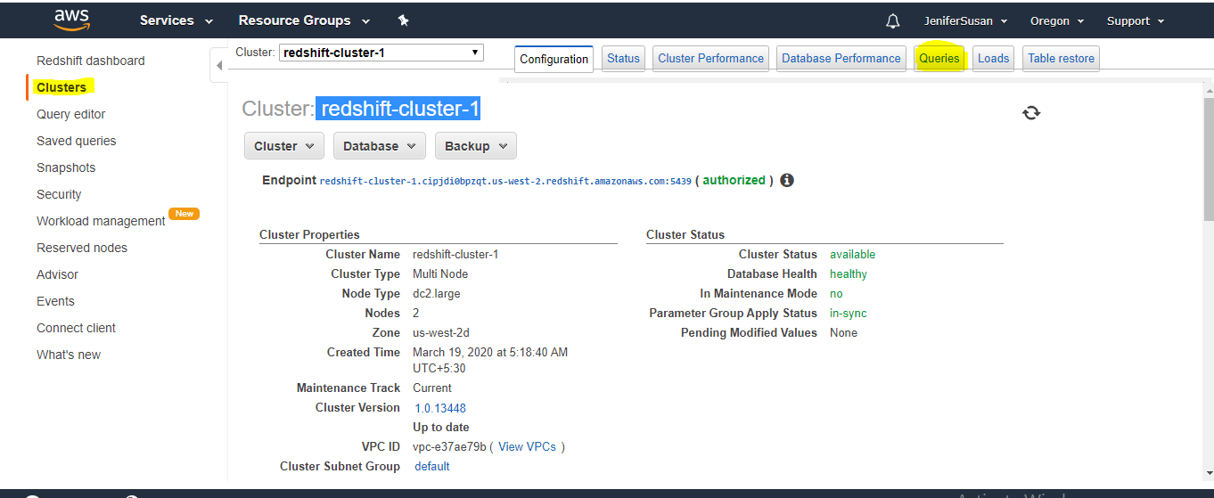

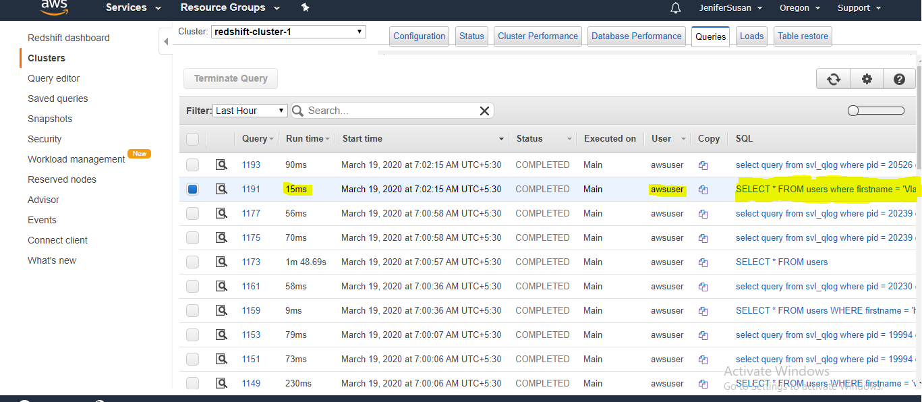

**To check the detail list of the particular query**

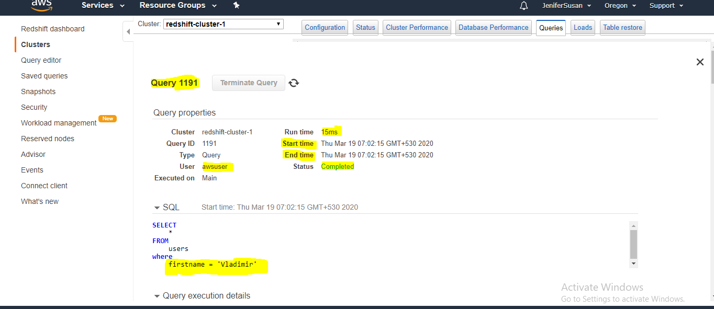

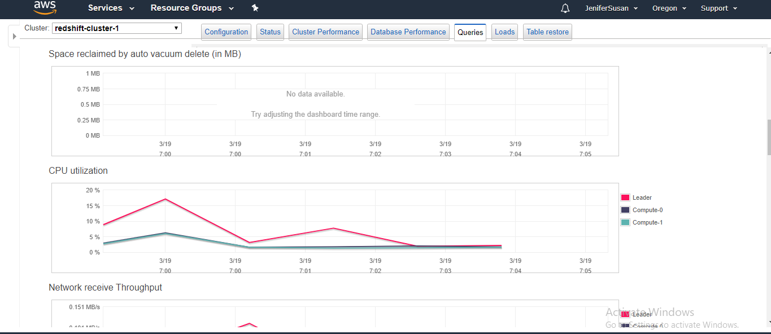

**Conculsion :**

1. you can analyses the particular query

2.who is the user who has long running query

3.who is the frequent user in the database

4.Historical data about the particular user.

You can collect further information about the user for better analytical work to improve the business or decision in the organization.

# Step 7: Reset Your Environment

# Amazon Redshift costs around $0.25 per hour

To delete the cluster

1. On the navigation menu, choose CLUSTERS to display your list of clusters.
2. Choose the redshift-cluster-1 For Actions, choose Delete. The Delete cluster page appears.
3. Confirm the cluster to be deleted, then choose Delete cluster.

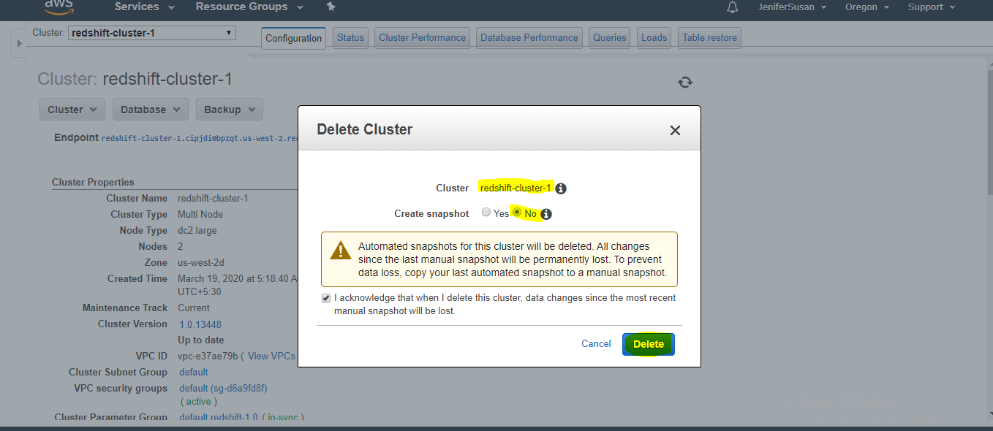

Interview questions

**1.What are the benefits of using AWS Redshift?**

Answer:

* We can run multiple queries on multiple nodes.
* We can use Postgresql, ODBC and JDBC.
* Automated backup
* Built-in security.
* When applications requires analytical function.
* Cost effective compared to traditional data warehousing technique.

#### What are the common features of Redshift?

AWS Redshift is a fully managed, petabyte-scale data warehouse service in the AWS, We can create a bunch of nodes once we have data warehouse created i.e AWS redshift Cluster. Now we can upload the set of data and perform the query for data analysis.

#### 3.What’s the use of redshift?

* Scalability up/down
* Pay for what ever we use

#### 4.Which is the database redshift is using?

Answer: Amazon Redshift is using PostgreSQL

#### 5.Why AWS redshift is named after Redshift?

Answer: Amazon Web Services given the name RedShift for Oracle trademark red.

#### 6.What is the difference between s3 and redshift?

Answer: AWS S3 is object based storage.  AWS Redshift is a fast, fully managed, petabyte-scale data warehouse.

#### 7.What is  cluster AWS cloud?

Answer: Cluster is grouping of similar services. You can create multiple clusters depends on the requirement on the services.

#### 8. Does redshift support unstructured data?

Answer: AWS Redshift is using  PostgreSQL supports only structured data.

#### 9.AWS Redshift is basically works on nodes and cluster and which of following option Redshift is based on?

Storage service  
database  
System Storage  
Answer: database

#### 10.What kind of application/services uses Redshift database?

Answer: Amazon Redshift is meant for services which are petabyte scale warehousing. Example: Big data analytics and OLAP. Redshift are fully managed and scalable in nature.

#### 11. What are the business intelligent tools to which Redshift can be integrated with?

Answer: Redshift can be integrated with Tableau, Jaspersoft, Microstrategy, Cognos Pentaho and Amazon QuickSight.

#### 12.How do we load data into Redshift?

Answer: Data is loaded from S3, DynamoDB,DMS and Read Replicas in RDS for example, when you have a RBS database but you want to do analytics on it to create a read replica,to pull that data from the read replica into Redshift and to do the analytics into Redshift.

#### 13.How many types of nodes supported by Redshift and what are the functions of nodes?

Answer: Redshift supports 2 nodes -leader node and compute node  
There is a leader node and the leader node is used to planning the queries and aggregate results across all compute nodes. So the compute nodes are going to actually be performing the queries and they will send the results back to the leader. If you have one node, then that nodes both a leader node and a compute node.

